


Validation of the global database

A part of BMT in Energy and Environment
Reference: RP_A870
Date: April 2010

www.waveclimate.com

Document status sheet

Title : Validation of the global database

Reference : RP_A870

Issue : 10

Date : April 19, 2010

Author(s) : P. Groenewoud, F.Melger

Reviewed by : C.F. de Valk

Revision history:

Issue | Date | Comment
10 | April 2009 | Included satellite data 2009 in the validation
9 | June 2009 | Included satellite data 2008 in the validation
8 | May 2008 | Included satellite data 2007 in the validation
7 | June 2007 | Included satellite data 2006 in the validation
6 | May 2006 | Included satellite data 2005 and model data 1992-2004 in the validation
5 | June 2005 | Included satellite data 2004 in the validation
4 | April 2004 | Included satellite data 2003 in the validation; model data 1998-2002
3 | October 2003 | Introduced model hindcast data 1998-1999
2 | April 2002 | Included satellite data 2001 in the validation
1 | October 2001 | Validation of the initial version of the satellite database

More detailed information can be found online at the history page of waveclimate.com.
Contents

List of tables 1
List of figures 2
1. Introduction 5
2. Statistical parameters used in the analysis 7
3. Validation of altimeter and scatterometer data 8
3.1. Error statistics of raw altimeter/scatterometer data 8
3.1.1. Summary 8
3.1.2. Least square fits of raw data 9
3.1.3. Statistics of raw data per year 9
3.1.4. Statistics of raw data per buoy 10
3.2. Error statistics of calibrated altimeter/scatterometer data 10
3.2.1. Summary 10
3.2.2. Least square fits of calibrated data 13
3.2.3. Statistics of calibrated data per year 13
3.2.4. Statistics of calibrated data per buoy 13
4. Calibration and validation of SAR data 14
4.1. Validation of SAR data 14
4.2. Calibration of SAR data 16
5. Calibration and validation of wave model data 18
5.1. Error statistics of raw wave model data 18
5.2. Error statistics of calibrated wave model data 20
Figures 22

List of tables

1 List of NOAA buoys used for validation.
2 Error statistics of raw wave height from altimeter based on all buoys.
3 Error statistics of raw wind speed from altimeter based on all buoys.
4 Error statistics of raw wind speed from scatterometer based on all buoys.
5 Year-dependent error statistics of raw wave height from Topex altimeter for all buoys.
6 Year-dependent error statistics of raw wind speed from Topex altimeter based on all buoys.
7 Calibration coefficients found for wave height from altimeter based on all buoys.
8 Calibration coefficients found for wind speed from altimeter based on all buoys.
9 Calibration coefficients found for wind speed from scatterometer based on all buoys.
10 Error statistics of calibrated wave height from altimeter based on all buoys.
11 Error statistics of calibrated wind speed from altimeter based on all buoys.
12 Error statistics of calibrated wind speed from scatterometer based on all buoys.
13 Statistics of raw wave height based on SAR/WAM spectra per region.
14 Statistics of raw mean period based on SAR/WAM spectra per region.
15 Statistics of raw zero-crossing period based on SAR/WAM spectra per region.
16 Statistics of raw height of long waves based on SAR/WAM spectra per region.
17 Statistics of raw wave height based on model spectra per region.
18 Statistics of raw mean period based on model spectra per region.
19 Statistics of raw zero-crossing period based on model spectra per region.
20 Statistics of raw height of long waves based on model spectra per region.
21 Statistics of calibrated wave height based on model spectra per region.
22 Statistics of calibrated mean period based on model spectra per region.
23 Statistics of calibrated zero-crossing period based on model spectra per region.
24 Statistics of calibrated model wind speed per region.

List of figures

1 Locations of NOAA buoys used in validation study.

Least squares fit of raw satellite data

2a Least squares fit of raw wave height for Topex altimeter and all buoys.
2b Least squares fit of raw wind speed for Topex altimeter and all buoys.
3a Least squares fit of raw wave height for Poseidon altimeter and all buoys.
3b Least squares fit of raw wind speed for Poseidon altimeter and all buoys.
4a Least squares fit of raw wave height for Geosat altimeter and all buoys.
4b Least squares fit of raw wind speed for Geosat altimeter and all buoys.
5a Least squares fit of raw wave height for Ers-1altimeter and all buoys.
5b Least squares fit of raw wind speed for Ers-1 altimeter and all buoys.
6a Least squares fit of raw wave height for Ers-2 altimeter and all buoys.
6b Least squares fit of raw wind speed for Ers-2 altimeter and all buoys.
7a Least squares fit of raw wave height for Jason-1 altimeter and all buoys.
7b Least squares fit of raw wind speed for Jason-1 altimeter and all buoys.
8a Least squares fit of raw wave height for GFO altimeter and all buoys.
8b Least squares fit of raw wind speed for GFO altimeter and all buoys.
9a Least squares fit of raw wave height for Envisat altimeter and all buoys.
9b Least squares fit of raw wind speed for Envisat altimeter and all buoys.
10a Least squares fit of raw wave height for Jason-2 altimeter and all buoys.
10b Least squares fit of raw wind speed for Jason-2 altimeter and all buoys.

11a Least squares fit of raw wind speed for Ers-1 scatterometer and all buoys.
11b Least squares fit of raw wind speed for Ers-2 scatterometer and all buoys.
11c Least squares fit of raw wind speed for Quikscat scatterometer and all buoys.

Bias and standard deviation over the years for raw satellite data

12a Bias and STD of error of raw wave height per year for Topex altimeter and all buoys.
12b Bias and STD of error of raw wind speed per year for Topex altimeter and all buoys.
13a Bias and STD of error of raw wave height per year for Poseidon altimeter and all buoys.
13b Bias and STD of error of raw wind speed per year for Poseidon altimeter and all buoys.
14a Bias and STD of error of raw wave height per year for Geosat altimeter and all buoys.
14b Bias and STD of error of raw wind speed per year for Geosat altimeter and all buoys.
15a Bias and STD of error of raw wave height per year for Ers-1 altimeter and all buoys.
15b Bias and STD of error of raw wind speed per year for Ers-1 altimeter and all buoys.
16a Bias and STD of error of raw wave height per year for Ers-2 altimeter and all buoys.
16b Bias and STD of error of raw wind speed per year for Ers-2 altimeter and all buoys.
17a Bias and STD of error of raw wave height per year for Jason-1 altimeter and all buoys.
17b Bias and STD of error of raw wind speed per year for Jason-1 altimeter and all buoys.
18a Bias and STD of error of raw wave height per year for GFO altimeter and all buoys.
18b Bias and STD of error of raw wind speed per year for GFO altimeter and all buoys.
19a Bias and STD of error of raw wave height per year for Envisat altimeter and all buoys.
19b Bias and STD of error of raw wind speed per year for Envisat altimeter and all buoys.
20a Bias and STD of error of raw wave height per year for Jason-2 altimeter and all buoys.
20b Bias and STD of error of raw wind speed per year for Jason-2 altimeter and all buoys.

21a Bias and STD of error of raw wind speed per year for Ers-1 scatterometer and all buoys.
21b Bias and STD of error of raw wind speed per year for Ers-2 scatterometer and all buoys.
21c Bias and STD of error of raw wind speed per year for Quikscat scatterometer and all buoys.

List of figures (continued)

Bias and standard deviation per buoy for raw satellite data

22a Bias and STD of error of raw wave height per buoy for Topex altimeter and all years.
22b Bias and STD of error of raw wind speed per buoy for Topex altimeter and all years.
23a Bias and STD of error of raw wave height per buoy for Poseidon altimeter and all years.
23b Bias and STD of error of raw wind speed per buoy for Poseidon altimeter and all years.
24a Bias and STD of error of raw wave height per buoy for Geosat altimeter and all years.
24b Bias and STD of error of raw wind speed per buoy for Geosat altimeter and all years.
25a Bias and STD of error of raw wave height per buoy for Ers-1 altimeter and all years.
25b Bias and STD of error of raw wind speed per buoy for Ers-1 altimeter and all years.
26a Bias and STD of error of raw wave height per buoy for Ers-2 altimeter and all years.
26b Bias and STD of error of raw wind speed per buoy for Ers-2 altimeter and all years.
27a Bias and STD of error of raw wave height per buoy for Jason-1 altimeter and all years.
27b Bias and STD of error of raw wind speed per buoy for Jason-1 altimeter and all years.
28a Bias and STD of error of raw wave height per buoy for GFO altimeter and all years.
28b Bias and STD of error of raw wind speed per buoy for GFO altimeter and all years.
29a Bias and STD of error of raw wave height per buoy for Envisat altimeter and all years.
29b Bias and STD of error of raw wind speed per buoy for Envisat altimeter and all years.
30a Bias and STD of error of raw wave height per buoy for Jason-2 altimeter and all years.
30b Bias and STD of error of raw wind speed per buoy for Jason-2 altimeter and all years.

31a Bias and STD of error of raw wave height per buoy for Ers-1 scatterometer and all years.
31b Bias and STD of error of raw wind speed per buoy for Ers-2 scatterometer and all years.
31c Bias and STD of error of raw wind speed per buoy for Quikscat scatterometer and all years.

Least squares fit of corrected satellite data

32a Least squares fit of corrected wave height for Topex altimeter and all buoys.
32b Least squares fit of corrected wave height for Topex altimeter and all buoys.
33a Least squares fit of corrected wave height for Poseidon altimeter and all buoys.
33b Least squares fit of corrected wind speed for Poseidon altimeter and all buoys.
34a Least squares fit of corrected wave height for Geosat altimeter and all buoys.
34b Least squares fit of corrected wind speed for Geosat altimeter and all buoys.
35a Least squares fit of corrected wave height for Ers-1 altimeter and all buoys.
35b Least squares fit of corrected wind speed for Ers-1 altimeter and all buoys.
36a Least squares fit of corrected wave height for Ers-2 altimeter and all buoys.
36b Least squares fit of corrected wind speed for Ers-2 altimeter and all buoys.
37a Least squares fit of corrected wave height for Jason-1 altimeter and all buoys.
37b Least squares fit of corrected wind speed for Jason-1 altimeter and all buoys.
38a Least squares fit of corrected wave height for GFO altimeter and all buoys.
38b Least squares fit of corrected wind speed for GFO altimeter and all buoys.
39a Least squares fit of corrected wave height for Envisat altimeter and all buoys.
39b Least squares fit of corrected wind speed for Envisat altimeter and all buoys.
40a Least squares fit of corrected wave height for Jason-2 altimeter and all buoys.
40b Least squares fit of corrected wind speed for Jason-2 altimeter and all buoys.

41a Least squares fit of corrected wind speed for Ers-1 scatterometer and all buoys.
41b Least squares fit of corrected wind speed for Ers-2 scatterometer and all buoys.
41c Least squares fit of corrected wind speed for Quikscat scatterometer and all buoys.

List of figures (continued)

Bias and standard deviation over the years for corrected satellite data

42a Bias and STD of error of corrected wave height per year for Topex altimeter and all buoys.
42b Bias and STD of error of corrected wind speed per year for Topex altimeter and all buoys.
43a Bias and STD of error of corrected wave height per year for Poseidon altimeter and all buoys.
43b Bias and STD of error of corrected wind speed per year for Poseidon altimeter and all buoys.
44a Bias and STD of error of corrected wave height per year for Geosat altimeter and all buoys.
44b Bias and STD of error of corrected wind speed per year for Geosat altimeter and all buoys.
45a Bias and STD of error of corrected wave height per year for Ers-1 altimeter and all buoys.
45b Bias and STD of error of corrected wind speed per year for Ers-1 altimeter and all buoys.
46a Bias and STD of error of corrected wave height per year for Ers-2 altimeter and all buoys.
46b Bias and STD of error of corrected wind speed per year for Ers-2 altimeter and all buoys.
47a Bias and STD of error of corrected wave height per year for Jason-1 altimeter and all buoys.
47b Bias and STD of error of corrected wind speed per year for Jason-1 altimeter and all buoys.
48a Bias and STD of error of corrected wave height per year for GFO altimeter and all buoys.
48b Bias and STD of error of corrected wind speed per year for GFO altimeter and all buoys.
49a Bias and STD of error of corrected wave height per year for Envisat altimeter and all buoys.
49b Bias and STD of error of corrected wind speed per year for Envisat altimeter and all buoys.
50a Bias and STD of error of corrected wave height per year for Jason-2 altimeter and all buoys.
50b Bias and STD of error of corrected wind speed per year for Jason-2 altimeter and all buoys.

51a Bias and STD of error of corrected wind speed per year for Ers-1 scatterometer and all buoys.
51b Bias and STD of error of corrected wind speed per year for Ers-2 scatterometer and all buoys.
51c Bias and STD of error of corrected wind speed per year for Quikscat scatterometer all buoys.

Bias and standard deviation per buoy for corrected satellite data

52a Bias and STD of error of corrected wave height per buoy for Topex altimeter and all years.
52b Bias and STD of error of corrected wind speed per buoy for Topex altimeter and all years.
53a Bias and STD of error of corrected wave height per buoy for Poseidon altimeter and all years.
53b Bias and STD of error of corrected wind speed per buoy for Poseidon altimeter and all years.
54a Bias and STD of error of corrected wave height per buoy for Geosat altimeter and all years.
54b Bias and STD of error of corrected wind speed per buoy for Geosat altimeter and all years.
55a Bias and STD of error of corrected wave height per buoy for Ers-1 altimeter and all years.
55b Bias and STD of error of corrected wind speed per buoy for Ers-1 altimeter and all years.
56a Bias and STD of error of corrected wave height per buoy for Ers-2 altimeter and all years.
56b Bias and STD of error of corrected wind speed per buoy for Ers-2 altimeter and all years.
57a Bias and STD of error of corrected wave height per buoy for Jason-1 altimeter and all years.
57b Bias and STD of error of corrected wind speed per buoy for Jason-1 altimeter and all years.
58a Bias and STD of error of corrected wave height per buoy for GFO altimeter and all years.
58b Bias and STD of error of corrected wind speed per buoy for GFO altimeter and all years.
59a Bias and STD of error of corrected wave height per buoy for Envisat altimeter and all years.
59b Bias and STD of error of corrected wind speed per buoy for Envisat altimeter and all years.
60a Bias and STD of error of corrected wave height per buoy for Jason-2 altimeter and all years.
60b Bias and STD of error of corrected wind speed per buoy for Jason-2 altimeter and all years.

61a Bias and STD of error of corrected wind speed per buoy for Ers-1 scatterometer and all years.
61b Bias and STD of error of corrected wind speed per buoy for Ers-2 scatterometer and all years.
61c Bias and STD of error of corrected wind speed per buoy for Quikscat scatterometer all years.

Introduction
Our internet service www.waveclimate.com provides worldwide wave and wind climate information based on microwave measurements from different satellites and sensors and on wave model computations. Sensors are altimeter (measuring significant wave height and wind speed), scatterometer (measuring the wind vector) and SAR Wave Mode (providing spectral wave information such as periods and directions). Satellites include GeoSat, ERS-1/2, Topex/Poseidon, GFO, Jason-1/2, Envisat and Quikscat. Validation and if necessary, calibration of wind and wave data in the database is regularly done by ARGOSS after each update of the database. It is based on wind and wave data from offshore NOAA buoys around North America and Hawaii shown in figure 1. We compare satellite data with buoy data, measured within a distance of 50 km and less than half an hour earlier or later. Wave model data is exported at the buoy locations every 3 hours.

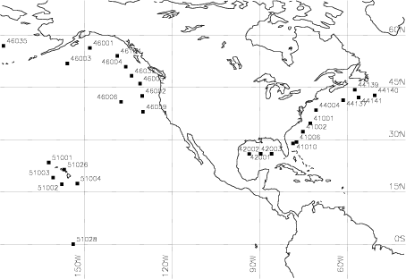

Figure 1 Locations of NOAA buoys used in validation study.

The table below lists each buoy’s position, region, observation period and the number of observations available.

Buoy | Nobs | Lat | Lon | Region | Begin | End
41001 | 149032 | 34.68 | -72.64 | Atlantic | 01jan85 | 08jun08
41002 | 150946 | 32.27 | -75.19 | Atlantic | 27feb85 | 30nov08
41006 | 99259 | 29.30 | -77.40 | Atlantic | 26may82 | 21apr96
41010 | 250045 | 28.90 | -78.53 | Atlantic | 10nov88 | 31dec09
42001 | 196010 | 25.93 | -89.65 | Gulf Of Mexico | 01jan85 | 31dec09
42002 | 193012 | 25.89 | -93.57 | Gulf Of Mexico | 01jan85 | 31dec09
42003 | 181573 | 25.94 | -85.91 | Gulf Of Mexico | 01jan85 | 31dec09
42039 | 64900 | 28.80 | -86.06 | Gulf Of Mexico | 01jan02 | 31dec09
42040 | 62004 | 29.21 | -88.20 | Gulf Of Mexico | 01jan02 | 05oct09
42041 | 23485 | 27.50 | -90.46 | Gulf Of Mexico | 08may02 | 16mar05
44004 | 158983 | 38.46 | -70.69 | Atlantic | 01jan85 | 08mar08
44005 | 162817 | 42.90 | -68.94 | Atlantic | 01jan85 | 31dec09
44008 | 63575 | 40.50 | -69.43 | Atlantic | 01jan01 | 06dec09
44011 | 59007 | 41.08 | -66.58 | Atlantic | 01jan01 | 22sep09
44137 | 36354 | 41.30 | -61.40 | Newfoundland | 30nov88 | 15oct97
44139 | 33325 | 44.30 | -57.40 | Newfoundland | 02dec88 | 21nov97
44140 | 25371 | 42.70 | -50.60 | Newfoundland | 05sep90 | 19nov96
44141 | 42892 | 42.10 | -56.10 | Newfoundland | 05sep90 | 08dec97
46001 | 179334 | 56.29 | -148.18 | Pacific | 01jan85 | 31dec09
46002 | 156312 | 42.53 | -130.26 | Pacific | 25jan85 | 28jul09
46003 | 100426 | 51.85 | -155.92 | Pacific | 01jan85 | 11aug99
46004 | 52622 | 50.90 | -135.90 | Pacific | 04aug88 | 31dec97
46005 | 158951 | 46.08 | -131.00 | Pacific | 01jan85 | 18dec08
46006 | 139094 | 40.84 | -137.49 | Pacific | 01jan85 | 21nov08
46035 | 167028 | 56.91 | -177.81 | Pacific | 13sep85 | 31dec09
46036 | 69879 | 48.30 | -133.90 | Pacific | 22sep87 | 31dec97
46047 | 66517 | 32.43 | -119.53 | Pacific | 01jan02 | 31dec09
46059 | 111158 | 37.98 | -130.00 | Pacific | 19oct94 | 09jan09
46066 | 46695 | 52.70 | -155.00 | Pacific | 01jan02 | 31dec09
46184 | 61634 | 54.00 | -138.80 | Pacific | 20sep87 | 31dec97
51001 | 180005 | 23.40 | -162.30 | Hawaii | 01jan85 | 24dec09
51002 | 180215 | 17.20 | -157.80 | Hawaii | 01jan85 | 31dec09
51003 | 179918 | 19.10 | -160.80 | Hawaii | 01jan85 | 31dec09
51004 | 173696 | 17.40 | -152.50 | Hawaii | 13feb85 | 07oct09
51026 | 30383 | 21.40 | -157.00 | Hawaii | 16jan93 | 23nov96
51028 | 62081 | 0.00 | -153.90 | Hawaii | 29oct97 | 14apr08
Table 1 List of NOAA buoys used for validation.

The results of validation and the calibration procedures applied to the data are presented in this report. Chapter 2 introduces the statistical parameters used for validation of the database in general. Analysis results of altimeter/scatterometer, SAR and wave model are discussed separately in chapters 3, 4 and 5 respectively. Most of the figures are plotted at the end of this report.

A short summary of the wave and wind data in the database, their validation and the relationship between sensors/satellites/models and wave and wind climate products is provided on www.waveclimate.com.

Statistical parameters used in the analysis
The error is defined as the difference between a retrieved satellite observation and a buoy measurement, so for wave height:

$$e_{i}=H_{i}^{\text{satellite}}−H_{i}^{\text{buoy}}$$

with $H_{i}^{\text{satellite}}$ the wave height of sample no. i retrieved from satellite data, and $H_{i}^{\text{buoy}}$ the coincident buoy measurement of the wave height. Coincident means that the retrieved satellite observation is located within 50 km around the buoy and that the observations do not differ more than 30 minutes in time. Bias, standard deviation of the error and correlation coefficient are defined as

$$\text{bias}=μ_{e}=n^{−1}\sum_{i=1,\text{.}\text{.},n}{e_{i}}$$

$$\text{stde}=\sqrt{(n−1)^{−1}\sum_{i=1,\text{.}\text{.},n}{(e_{i}−μ_{e})^{2}}}$$

$$\text{correlation}=\frac{σ_{\text{SB}}}{σ_{S}σ_{B}}$$

$$σ_{B}=σ_{\text{buoy}}=\sqrt{(n−1)^{−1}\sum_{i=1,\text{.}\text{.},n}{(H_{i}^{\text{buoy}}−H_{\text{mean}}^{\text{buoy}})^{2}}}$$

where $σ_{S},σ_{B},σ_{\text{SB}}$ denote the standard deviation of the satellite, the standard deviation of the buoy and the co-variance of the satellite and the buoy respectively.

Apart from bias, standard deviation of the error and correlation coefficient, the quality of the data is expressed in terms of the relative root-mean-square error (RRMSE). The root-mean-square error of say, significant wave height, is

$$\text{RMSE}=\sqrt{ n^{−1}\sum_{i=1,\text{.}\text{.},n}{{\left|H_{i}^{\text{satellite}}−H_{i}^{\text{buoy}}\right|}^{2}}}$$

It is similar to the standard deviation, but also includes the bias error. The relative error is the root-mean-square error normalised by the root-mean-square value of the buoy wave height:

$$\text{RRMSE}=\sqrt{\frac{\sum_{i=1,\text{.}\text{.},n}{{\left|H_{i}^{\text{satellite}}−H_{i}^{\text{buoy}}\right|}^{2}}}{\sum_{i=1,\text{.}\text{.},n}{{\left|H_{i}^{\text{buoy}}\right|}^{2}}}}$$

Validation of altimeter and scatterometer data
Validation results of altimeter are based on data from January 1985 until December 2009. Scatterometer results are based on data from March 1992 until December 2009.

The parameters analysed are significant wave height (from altimeter) and wind speed (from scatterometer and altimeter). Results are presented separately for the different sensors and satellites. First, the validation and calibration of raw altimeter and scatterometer data (before calibration) is addressed. Then the validation results of the calibrated data are given.

Error statistics of raw altimeter/scatterometer data

Summary

Below, the quality of the raw significant wave height obtained by the altimeters of the various satellites is summarised. The Topex/Poseidon and the Geosat satellites deliver the most accurate wave height estimates. Ers-1 altimeter data is somewhat less accurate. Table 2 shows the quality of the raw wave height obtained by the altimeters of the various satellites.

Satellite | No. of samples | Buoy  Mean [m] | STD  Error [m] | Correlation  Coefficient  [-] | Relative  RMSE  [%] | Bias  [m]
Topex | 7696 | 2.30 | 0.26 | 0.98 | 10 | –0.02
Poseidon | 524 | 2.27 | 0.32 | 0.97 | 12 | 0.02
Geosat | 1598 | 2.31 | 0.29 | 0.97 | 11 | -0.03
Ers-1 | 2706 | 2.35 | 0.37 | 0.96 | 22 | -0.46
Ers-2 | 7433 | 2.07 | 0.36 | 0.96 | 16 | –0.16
Jason-1 | 5421 | 2.05 | 0.31 | 0.96 | 14 | –0.08
GFO | 3849 | 2.17 | 0.26 | 0.98 | 14 | –0.23
Envisat | 4241 | 2.06 | 0.27 | 0.98 | 12 | 0.07
Jason-2 | 944 | 1.95 | 0.31 | 0.96 | 14 | -0.03
Table 2 Error statistics of raw wave height from altimeter based on all buoys.

Raw wind speed is most reliably estimated using the scatterometers of Quikscat and the Ers-satellites. Wind speed measured by the Geosat altimeter is much less accurate than wind speed from other sources. Tables 3 and 4 show the quality of the raw wind speed obtained by the altimeters and scatterometers of the various satellites.

Satellite | No. of samples | Buoy  Mean [m/s] | STD  Error [m/s] | Correlation  Coefficient  [-] | Relative  RMSE  [%] | Bias  [m/s]
Topex | 7696 | 7.50 | 1.55 | 0.91 | 19 | 0.06
Poseidon | 524 | 7.86 | 1.70 | 0.90 | 20 | 0.10
Geosat | 1598 | 7.74 | 2.47 | 0.77 | 30 | -0.69
Ers-1 | 2706 | 7.82 | 1.59 | 0.91 | 19 | -0.51
Ers-2 | 7433 | 7.05 | 1.57 | 0.91 | 21 | –0.37
Jason-1 | 5421 | 6.99 | 1.47 | 0.91 | 19 | –0.21
GFO | 3849 | 7.01 | 1.43 | 0.93 | 19 | 0.37
Envisat | 4241 | 6.98 | 1.37 | 0.92 | 18 | 0.12
Jason-2 | 944 | 6.84 | 1.55 | 0.90 | 22 | 0.64
Table 3 Error statistics of raw wind speed from altimeter based on all buoys.

Satellite | No. of samples | Buoy  Mean [m/s] | STD  Error [m/s] | Correlation  Coefficient  [-] | Relative  RMSE  [%] | Bias  [m/s]
Ers-1 | 9402 | 7.85 | 1.20 | 0.94 | 15 | -0.54
Ers-2 | 8778 | 7.46 | 1.15 | 0.94 | 16 | -0.56
Quikscat | 64721 | 6.94 | 1.14 | 0.94 | 15 | 0.25
Table 4 Error statistics of raw wind speed from scatterometer based on all buoys.

Least square fits of raw data

Least square fits of linear relationships between raw satellite data and buoy data of wave height and wind speed are given per satellite-sensor pair in figures 2 - 11. Satellite data are on the vertical axis, buoy data on the horizontal axis. For reference, we also plotted the ‘y=x’ line and the sorted satellite observations against the sorted buoy observations. The equation of the linear fits, with scale factor a and translation b, is

$$H^{\text{satellite}}=a⋅H^{\text{buoy}}+b$$

The fitting procedure applied is Total Least Squares, minimising the sum of squares of the residuals measured orthogonal to the fitted line. Minimising distances in y-direction only, e.g. assuming noise in satellite data only, proved to be sensitive to switching x and y, indicating that this procedure would result in seriously biased estimates. Please note the almost perfect fit of Geosat wave heights in figure 4a and on the other hand the large scatter in raw Geosat wind speeds shown in figure 4b.

Statistics of raw data per year

We analysed the statistics per satellite-sensor combination per year for all buoys in order to search for irregularities over time. Bias (satellite observation minus buoy observation) and standard deviation of the error in raw data are shown over the years per data source in figures 12 - 21.

From figure 12a, we see that the bias in Topex raw wave height increases significantly in 1998. This appears to be caused by a performance degradation of the chirp generator. A switchover to the backup altimeter was successfully realised on February 9, 1999. Therefore, we derived separate calibration coefficients for 1998 for wave height and wind speed from Topex. Tables 5 and table 6 show the error statistics of Topex data for 1998 and for the years 1992-2005, excluding 1998.

Period | No. of samples | Buoy  Mean [m] | STD  Error [m] | Correlation  Coefficient  [-] | Relative  RMSE  [%] | Bias  [m]
1998 | 498 | 2.41 | 0.32 | 0.97 | 14 | 0.21
1992 – 2005  (excl. 1998) | 7198 | 2.29 | 0.25 | 0.98 | 10 | –0.04
Table 5 Year-dependent error statistics of raw wave height from Topex altimeter based on all buoys.

Period | No. of samples | Buoy  Mean [m/s] | STD  Error [m/s] | Correlation  Coefficient  [-] | Relative  RMSE  [%] | Bias  [m/s]
1998 | 498 | 7.96 | 1.45 | 0.91 | 17 | 0.12
1992 - 2005  (excl. 1998) | 7198 | 7.46 | 1.59 | 0.91 | 19 | 0.05
Table 6 Year-dependent error statistics of raw wind speed from Topex altimeter based on all buoys.

The relatively large biases of Topex wind speed in 1992 and 2000, shown in figure 12b, are unexplained. Luckily, the number of samples analysed in 1992 is relatively small: 168, 559, 493, 609, 615, 595, 457, 410, 451 and 406 samples were used over the years 1992-2001.

Bias of Poseidon data seems to get worse in 2001 as compared to the years before, according to Figures 13a and 13b. However, the reliability of the 2001 results is small due to the fact that too few samples were available in 2001 (10 samples were available in January 2001, whereas earlier years have at least 40 samples typically from 5 or 6 months).

According to figure 14b, Geosat winds show a large negative bias in 1985. Gradually, the bias reduces until 1989. The standard deviation of the error in Geosat wind speed is large (2 m/s or more) for all years. Therefore, Geosat wind speed is not used by the online service.

The quality of wind speed measured by Geosat follow-on (GFO) deteriorates as of 2007 (see figure 18b). For this reason, the online service only uses GFO wind speed from the years 2002-2006. Wave height observations from GFO proof to be reliable for all years (fig. 18a).

Statistics of raw data per buoy

We analysed the statistics per satellite-sensor combination per buoy for all years in order to detect suspect buoys. Bias and standard deviation of the error per buoy are given for each satellite-sensor pair in figures 22 - 31. From these figures we see that the buoys near Newfoundland (numbers starting with 44) and the buoys in the Pacific (numbered 46..) show a larger standard deviation of the error than the buoys in the Gulf of Mexico (numbered 42..), in the Atlantic (41..) and the buoys near Hawai (51..). This is related to the fact that mean absolute wave height (and wind speed) is larger near Newfoundland and in the Pacific.

Error statistics of calibrated altimeter/scatterometer data

Summary

Calibration coefficients derived from linear least squares fits (see 3.1.2), i.e. slope (α) and intercept (β) have been determined per satellite-sensor combination in order to calibrate the raw satellite data:

$$H_{i}^{\text{corrected}}=α⋅H_{i}^{\text{raw}}+β$$

where α and β relate to the coefficients of the linear least square fits of the raw data to buoy data according to

$α=1/a$ and $β={−b}/a$

The use of non-linear curve fitting did not improve the fits significantly. Note that (the smoothed version of) the sorted satellite versus buoy observations curve is such a non-linear curve.

Calibration coefficients for Topex are taken year-dependent. For the other satellites, calibrations are valid for all relevant years. The following calibration coefficients were found:

Satellite | Period | α [-] | β [m]
Topex | 1998 | 1.07 | -0.40
Topex | 1992-2005  excl. 1998 | 1.06 | –0.09
Poseidon | 1992-2002 | 1.02 | -0.05
Geosat | 1985-1989 | 0.98 | 0.09
Ers-1 | 1991-1996 | 1.14 | 0.20
Ers-2 | 1995-2009 | 1.06 | 0.04
Jason-1 | 2002-2009 | 1.05 | –0.03
GFO | 2002-2008 | 1.08 | 0.07
Envisat | 2003-2009 | 1.05 | -0.19
Jason-2 | 2008-2009 | 1.02 | -0.00
Table 7 Calibration coefficients found for wave height from altimeter based on all buoys.

Satellite | Period | α [-] | β [m]
Topex | 1998 | 1.00 | -0.15
Topex | 1992-2005  excl. 1998 | 0.93 | 0.51
Poseidon | 1992-2002 | 0.95 | 0.34
Geosat | 1985-1989 | 0.94 | 1.11
Ers-1 | 1991-1996 | 1.03 | 0.27
Ers-2 | 1995-2009 | 0.90 | 1.03
Jason-1 | 2002-2009 | 0.93 | 0.66
GFO | 2002-2006 | 0.87 | 0.61
Envisat | 2003-2009 | 0.95 | 0.22
Jason-2 | 2008-2009 | 0.88 | 0.23
Table 8 Calibration coefficients found for wind speed from altimeter based on all buoys.

Satellite | Period | α [-] | β [m/s]
Ers-1 | 1992-1996 | 1.07 | 0.02
Ers-2 | 1996-2000 | 1.06 | 0.10
Quikscat | 2000-2009 | 1.00 | -0.24
Table 9 Calibration coefficients found for wind speed from scatterometer based on all buoys.

Our internet service www.waveclimate.com applies the above calibration to the raw satellite data except for Geosat winds. Winds from Geosat are too inaccurate, so they are not used by the online service. From table 7-9, we see that calibration increases wave height by up to 14% (for Ers-1 altimeter). They also confirm that, at least at open sea, scatterometer winds are more reliable than altimeter winds.
Applying the above calibration to the raw satellite data, we get the following error statistics of the calibrated satellite data:

Satellite | No. of samples | Buoy  Mean [m] | STD  Error [m] | Correlation  Coefficient  [-] | Relative  RMSE  [%] | Bias  [m]
Topex | 7696 | 2.30 | 0.25 | 0.98 | 10 | 0.00
Poseidon | 524 | 2.27 | 0.32 | 0.97 | 12 | 0.02
Geosat | 1598 | 2.31 | 0.29 | 0.97 | 11 | 0.02
Ers-1 | 2706 | 2.35 | 0.36 | 0.96 | 14 | 0.01
Ers-2 | 7433 | 2.07 | 0.36 | 0.96 | 15 | -0.01
Jason-1 | 5421 | 2.05 | 0.31 | 0.96 | 13 | -0.01
GFO | 3849 | 2.17 | 0.26 | 0.98 | 10 | -0.01
Envisat | 4241 | 2.06 | 0.27 | 0.98 | 11 | -0.01
Jason-2 | 944 | 1.95 | 0.30 | 0.97 | 13 | -0.00
Table 10 Error statistics of calibrated wave height from altimeter based on all buoys.

Satellite | No. of samples | Buoy  Mean [m/s] | STD  Error [m/s] | Correlation  Coefficient  [-] | Relative  RMSE  [%] | Bias  [m/s]
Topex | 7696 | 7.50 | 1.51 | 0.91 | 18 | 0.02
Poseidon | 524 | 7.86 | 1.64 | 0.90 | 19 | 0.04
Geosat | 1598 | 7.74 | 2.39 | 0.77 | 28 | -0.00
Ers-1 | 2706 | 7.82 | 1.61 | 0.91 | 19 | -0.01
Ers-2 | 7433 | 7.05 | 1.46 | 0.91 | 19 | -0.01
Jason-1 | 5421 | 6.99 | 1.40 | 0.91 | 18 | -0.03
GFO | 3849 | 7.01 | 1.26 | 0.93 | 16 | 0.02
Envisat | 4241 | 6.98 | 1.33 | 0.92 | 17 | -0.01
Jason-2 | 944 | 6.84 | 1.41 | 0.90 | 19 | -0.03
Table 11 Error statistics of calibrated wind speed from altimeter based on all buoys.

Satellite | No. of samples | Buoy  Mean [m/s] | STD  Error [m/s] | Correlation  Coefficient  [-] | Relative  RMSE  [%] | Bias  [m/s]
Ers-1 | 9402 | 7.85 | 1.22 | 0.94 | 14 | -0.01
Ers-2 | 8778 | 7.46 | 1.16 | 0.94 | 14 | 0.03
Quikscat | 57408 | 6.94 | 1.12 | 0.94 | 15 | 0.03
Table 12 Error statistics of calibrated wind speed from scatterometer based on all buoys.

Relative RMSE of the calibrated satellite data (listed in tables 10-12) is indeed smaller than relative RMSE of the raw satellite data (listed in tables 2-4). Especially wave height from Ers-1 (22% reduces to 14%) and GFO (14% reduces to 10%) altimeters and wind speed from altimeters onboard GFO (19% reduces to 16%) and Jason-2 (22% reduces to 19%) show smaller errors after calibration.

Least square fits of calibrated data

As a confirmation of the correction procedure, least square fits for calibrated wave height and calibrated wind speed are given per satellite-sensor pair in figures 32-41. As expected, fitting the calibrated satellite data to the buoy data yields ‘y=x’ fits, i.e. a=1 and b=0.

Statistics of calibrated data per year

Bias (satellite observation minus buoy observation) and standard deviation of the error in calibrated data are shown per data source in figures 42 - 51.

Statistics of calibrated data per buoy

Bias and standard deviation of the error per buoy are given for the calibrated data for each satellite-sensor pair in figures 52 - 61.

Calibration and validation of SAR data

Validation of SAR data
Validation results of SAR are based on SAR data from April 1993 until June 2003.

For the validation the buoys are grouped into 5 geographical regions: Atlantic, Gulf of Mexico, Newfoundland, Pacific and Hawaii. The wave climate within a region is more or less uniform. The buoys and regions are given in Table 1.

The results of the most important statistic parameters are given for the significant wave height (Hs), mean period (Tm) and zero-crossing period (Tz). The spectral SAR data are especially useful for wave climates that exhibit large waves (wavelength > 200m and period > 12 sec). Therefore we also considered the wave height for long waves (wave period exceeds 12 seconds, HT>12).

The Hs, Tm, Tz and HT>12 statistics for all buoys and years are collected in the tables below for the merged WAM-SAR spectra.

 | Atlantic | Gulf of Mexico | Newfoundland | Pacific | Hawaii
N | 348 | 193 | 69 | 454 | 313
Mean [m] | 1.97 | 1.29 | 2.85 | 2.95 | 2.25
Bias [m] | –0.08 | –0.06 | 0.07 | 0.04 | –0.08
StDev [m] | 0.50 | 0.33 | 0.59 | 0.46 | 0.33
Rrmse [%] | 22 | 22 | 19 | 14 | 14
Corr | 0.89 | 0.92 | 0.91 | 0.95 | 0.88
Table 13 Statistics of raw wave height based on SAR/WAM spectra per region.

 | Atlantic | Gulf of Mexico | Newfoundland | Pacific | Hawaii
N | 348 | 193 | 69 | 454 | 313
Mean [s] | 7.20 | 5.92 | 8.61 | 9.32 | 8.80
Bias [s] | 0.14 | 0.34 | 0.26 | 0.29 | 0.21
StDev [s] | 0.99 | 1.60 | 0.90 | 0.73 | 0.63
Rrmse [%] | 14 | 29 | 11 | 9 | 8
Corr | 0.68 | 0.42 | 0.79 | 0.93 | 0.93
Table 14 Statistics of raw mean period based on SAR/WAM spectra per region.

 | Atlantic | Gulf of Mexico | Newfoundland | Pacific | Hawaii
N | 348 | 193 | 69 | 454 | 313
Mean [s] | 5.88 | 4.95 | 6.98 | 7.30 | 6.80
Bias [s] | 0.00 | 0.01 | 0.25 | 0.24 | 0.14
StDev [s] | 0.75 | 1.27 | 0.83 | 0.61 | 0.53
Rrmse [%] | 13 | 25 | 13 | 9 | 8
Corr | 0.70 | 0.40 | 0.74 | 0.92 | 0.92
Table 15 Statistics of raw zero-crossing period based on SAR/WAM spectra period per region.

 | Atlantic | Gulf of Mexico | Newfoundland | Pacific | Hawaii
N | 348 | 193 | 69 | 454 | 313
Mean [m] | 0.40 | 0.17 | 1.05 | 1.47 | 0.94
Bias [m] | 0.08 | 0.13 | 0.14 | 0.12 | 0.03
StDev [m] | 0.36 | 0.22 | 0.50 | 0.44 | 0.30
Rrmse [%] | 71 | 135 | 41 | 25 | 27
Corr | 0.64 | 0.64 | 0.85 | 0.94 | 0.90
Table 16 Statistics of raw height of long waves (T>12 s) based on SAR/WAM spectra per region.

The best results are obtained in the Pacific and Hawaii. The worst results in the Gulf of Mexico. This can be explained by the fact that SAR data is especially useful for a wave climate that exhibits long waves, which are lacking in the Gulf of Mexico. This is also reflected by the results in the last table, i.e. the mean wave height for long waves in the Gulf of Mexico is a fraction of the mean wave heights for the other regions.

Calibration of SAR data

Since the end of August 2002, wave heights and wave periods derived from SAR are calibrated on the fly with altimeter wave heights by waveclimate.com, in order to ensure consistency of the wave height distributions from both data sources. Note that this calibration has not been taken into account in the validation results for SAR wave height presented in this document.

In order to remove inconsistencies between significant wave height from SAR and significant wave height from altimeter, waveclimate.com corrects the offshore SAR significant wave height using altimeter wave heights. The correction is performed on-the-fly as it depends on the offshore area under investigation. Corrections of a few percent are typical. Maximum correction for SAR wave height is about 15%.

It is assumed that wave heights from altimeter and SAR are statistically correlated (altimeter and SAR wave height samples used come from the same area but are not collocated in time).

Correction of total SAR wave height (based on the total spectrum) is done as follows:

$$H_{i}^{\text{corrected}}=\sqrt{α⋅H_{i}^{2}+β⋅s_{i}}$$

where $i$ counts the SAR samples, $H_{i}^{\text{corrected}}$and $H_{i}$denote the corrected and total SAR wave height retrieved from the global database respectively, α is slope and β is intercept. The factor $s_{i}$ ensures a smooth transition near zero. It is found as

$$s_{i}=1−\text{exp}(−H_{i}^{2}⋅\left|\frac{α}{β}\right|)$$

To correct wave height based on either wind-sea or swell part of the SAR spectrum, a weight factor $F_{i}$is introduced to divide intercept (β) proportionally to the energy in the wind-sea/swell part of the spectrum:

where $\text{Hswell}$ and $\text{Hsea}$ denote wave height based on the swell and wind-sea part of the spectrum respectively, satisfying

${\text{Hswell}}_{i}^{2}+{\text{Hsea}}_{i}^{2}=H_{i}^{2}$.

Weight factors are found as

${\text{Fswell}}_{i}={{\text{Hswell}}_{i}^{2}}/{H_{i}^{2}}$and ${\text{Fsea}}_{i}={{\text{Hsea}}_{i}^{2}}/{H_{i}^{2}}$

Calibration of mean wave period and zero-crossing wave period makes use of the correction computed for wave height:

The same scaling factor is applied for calibration of wave periods of swell and wind-sea.

Slope (α) and intercept (β) relate to the coefficients of the linear regression fit of SAR total wave energy quantiles to altimeter wave energy quantiles:

$H_{\text{SAR}}^{2}=a⋅H_{\text{ALT}}^{2}+b+ε$

with ε a residual. Regression of SAR energy on altimeter energy assumes that altimeter wave height is more accurate than SAR wave height, which is what we find in the validation against buoys. In the regression, we minimize the sum of squares of $ε/\text{max}(0\text{.}\text{25},H_{\text{ALT}})$, so we assume that the standard deviation of the residual is proportional to the altimeter wave height.

In the correction of total SAR wave height above,

$α=1/a$ and $β={−b}/a$.

Calibration and validation of wave model data
Validation results of the global wave model are based on data from 1992 until 2004.

For the validation the buoys are grouped into the same 5 geographical regions as used for validation of SAR (Chapter 4.1). Error statistics are given for raw wave model data (section 5.1) and for wave model data calibrated with altimeter data (section 5.2) In waveclimate.com, the calibrated wave model data is used.

Error statistics of raw wave model data

The Hs, Tm, Tz and HT>12 statistics for all buoys and years are collected in the tables below for the computed wave model spectra.

 | Atlantic | Gulf of Mexico | Pacific | Hawaii
N | 148218 | 143325 | 236215 | 150378
Mean [m] | 1.66 | 1.00 | 2.76 | 2.31
Bias [m] | –0.18 | -0.09 | -0.03 | -0.03
StDev [m] | 0.42 | 0.27 | 0.52 | 0.36
Rrmse [%] | 22 | 22 | 16 | 15
Corr | 0.92 | 0.93 | 0.93 | 0.87
Table 17 Statistics of raw significant wave height based on model spectra per region
.

 | Atlantic | Gulf of Mexico | Pacific | Hawaii
N | 148218 | 143325 | 236215 | 150378
Mean [s] | 6.41 | 4.76 | 8.67 | 8.69
Bias [s] | -0.56 | -0.58 | -0.19 | 0.09
StDev [s] | 0.79 | 0.64 | 0.96 | 0.90
Rrmse [%] | 14 | 16 | 11 | 10
Corr | 0.81 | 0.78 | 0.85 | 0.85
Table 18 Statistics of raw mean period based on model spectra per region.

 | Atlantic | Gulf of Mexico | Pacific | Hawaii
N | 148218 | 143325 | 236215 | 150378
Mean [s] | 5.33 | 4.26 | 6.81 | 6.71
Bias [s] | -0.45 | -0.49 | -0.17 | 0.03
StDev [s] | 0.61 | 0.53 | 0.69 | 0.61
Rrmse [%] | 13 | 15 | 10 | 9
Corr | 0.81 | 0.77 | 0.87 | 0.86
Table 19 Statistics of raw zero-crossing period based on model spectra period per region.

 | Atlantic | Gulf of Mexico | Pacific | Hawaii
N | 125500 | 6515 | 235395 | 150108
Mean [m] | 0.21 | 0.23 | 1.15 | 0.97
Bias [m] | -0.16 | -0.07 | -0.08 | 0.06
StDev [m] | 0.36 | 0.44 | 0.53 | 0.36
Rrmse [%] | 59 | 59 | 32 | 32
Corr | 0.78 | 0.82 | 0.89 | 0.86
Table 20 Statistics of raw height of long waves (T>12 s) based on model spectra per region.

As for SAR, best results are obtained in the Pacific and Hawaii and the worst results in the Gulf of Mexico. In general results are comparable to the SAR results presented in Chapter 4. From the bias we see that (as opposed to the SAR results, where wave periods are somewhat overestimated) the model tends to underestimate the wave period in the Atlantic, in the Gulf of Mexico and in the Pacific. Note that the number of observations (N) is much higher than for SAR: the wave model generates 3-hourly time series exactly at the locations of the buoys.

Error statistics of calibrated wave model data

Wave heights and wave periods computed by the wave model are calibrated with altimeter wave heights. As opposed to SAR, where calibration coefficients are computed and applied on the fly using altimeter data from the area of interest, wave model parameters are corrected with preset calibration coefficients, i.e. slope and intercept. The calibration coefficients are computed offline per wave model grid point. Linear regression is performed on wave model and altimeter wave energy samples collocated in space and time. Slope and intercept are applied to wave height in the same way as for SAR (see section 4.2).

In table 21, error statistics are given for total wave height after calibration with altimeter data:

 | Atlantic | Gulf of Mexico | Pacific | Hawaii
N | 148218 | 143325 | 236215 | 150378
Mean [m] | 1.77 | 1.06 | 2.73 | 2.21
Bias [m] | -0.07 | -0.03 | -0.07 | -0.13
StDev [m] | 0.42 | 0.27 | 0.50 | 0.34
Rrmse [%] | 20 | 21 | 16 | 15
Corr | 0.92 | 0.93 | 0.94 | 0.88

Table 21 Statistics of calibrated wave height based on model spectra per region.

In tables 22 and 23, error statistics are given for mean wave period and for zero-crossing wave period after calibration with altimeter data:

 | Atlantic | Gulf of Mexico | Pacific | Hawaii
N | 148218 | 143325 | 236215 | 150378
Mean [s] | 6.63 | 5.01 | 8.63 | 8.53
Bias [s] | -0.34 | -0.33 | -0.24 | -0.07
StDev [s] | 0.81 | 0.65 | 0.97 | 0.92
Rrmse [%] | 12 | 13 | 11 | 11
Corr | 0.80 | 0.75 | 0.85 | 0.84

Table 22 Statistics of calibrated mean period based on model spectra per region.

 | Atlantic | Gulf of Mexico | Pacific | Hawaii
N | 148218 | 143325 | 236215 | 150378
Mean [s] | 5.51 | 4.49 | 6.77 | 6.58
Bias [s] | -0.26 | -0.26 | -0.20 | -0.09
StDev [s] | 0.63 | 0.56 | 0.68 | 0.61
Rrmse [%] | 12 | 13 | 10 | 9
Corr | 0.81 | 0.72 | 0.87 | 0.85

Table 23 Statistics of calibrated zero-crossing period based on model spectra period per region.

Comparison of table 17 and table 21 shows that calibration of the model with altimeter data somewhat improves bias and relative error of significant wave height in the Atlantic and in the Gulf of Mexico. Bias of significant wave height becomes a bit worse near Hawaii.

Calibration significantly improves bias and relative error of mean period (compare tables 18 and 22) and zero-crossing period (compare tables 19 and 23) in the Atlantic and in the Gulf of Mexico.

Wind speed is calibrated with altimeter wind speed before it is used by the wave model. As a result, waveclimate.com only uses calibrated model wind. As for wave parameters, the calibration coefficients for wind speed are computed offline and per wave model grid point. Linear regression is performed on wave model and altimeter wind speed samples collocated in space and time. Slope and intercept are applied as follows:

${\text{Ws}}_{i}^{\text{corrected}}=α_{j}⋅{\text{Ws}}_{i}+β_{j}$,

where i is the sample index and j the grid point index.

Table 24 gives the error statistics of calibrated model wind speed:

 | Atlantic | Gulf of Mexico | Pacific | Hawaii
N | 68853 | 35993 | 136791 | 72725
Mean [m/s] | 6.99 | 5.91 | 7.87 | 6.99
Bias [m/s] | 0.09 | -0.29 | 0.34 | -0.31
StDev [m/s] | 2.16 | 1.71 | 2.47 | 1.76
Rrmse [%] | 28 | 25 | 30 | 23
Corr | 0.82 | 0.83 | 0.78 | 0.76

Table 24 Statistics of calibrated model wind speed per region.

Calibration of model wind with altimeter wind tends to decrease the bias between observed wind and model wind. Relative errors do not change much. We think that calibration of model wind gets more important at near shore locations (the buoys we used for validation here are at offshore locations).

Figures

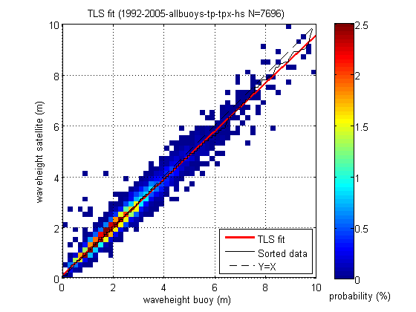
Figure 2a Least squares fit of raw wave height for Topex altimeter and all buoys.
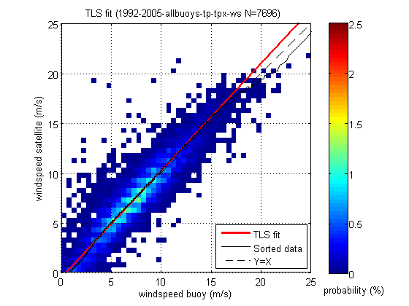
Figure 2b Least squares fit of raw wind speed for Topex altimeter and all buoys.
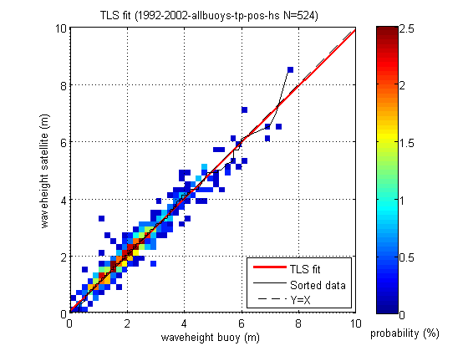
Figure 3a Least squares fit of raw wave height for Poseidon altimeter and all buoys.
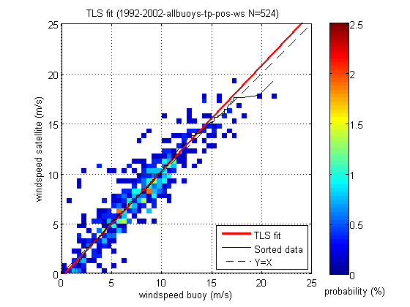
Figure 3b Least squares fit of raw wind speed for Poseidon altimeter and all buoys.
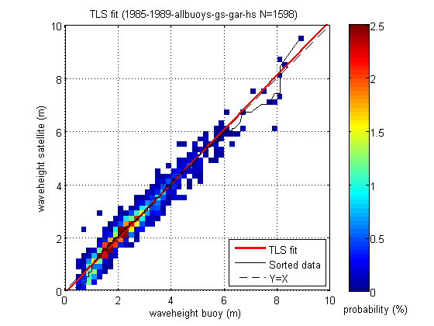
Figure 4a Least squares fit of raw wave height for Geosat altimeter and all buoys.
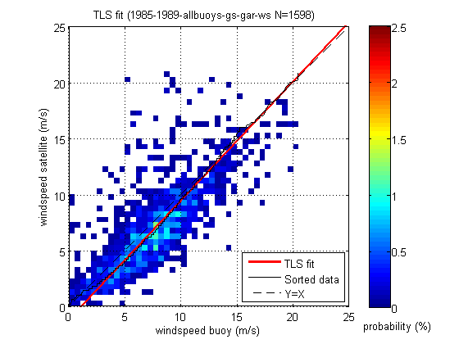
Figure 4b Least squares fit of raw wind speed for Geosat altimeter and all buoys.
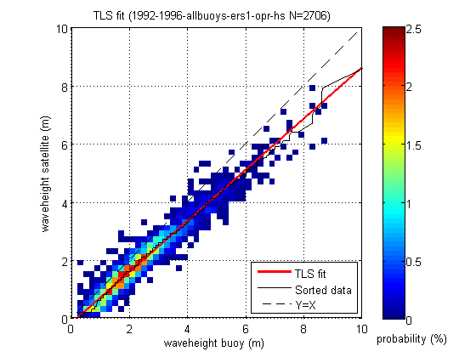
Figure 5a Least squares fit of raw wave height for Ers-1 altimeter and all buoys.
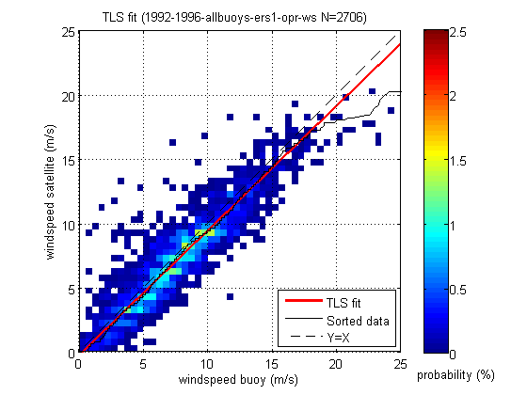
Figure 5b Least squares fit of raw wind speed for Ers-1 altimeter and all buoys.
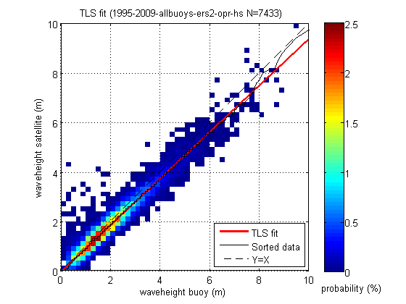
Figure 6a Least squares fit of raw wave height for Ers-2 altimeter and all buoys.
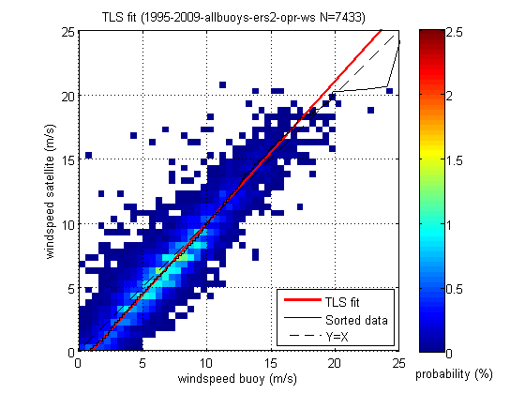
Figure 6b Least squares fit of raw wind speed for Ers-2 altimeter and all buoys.
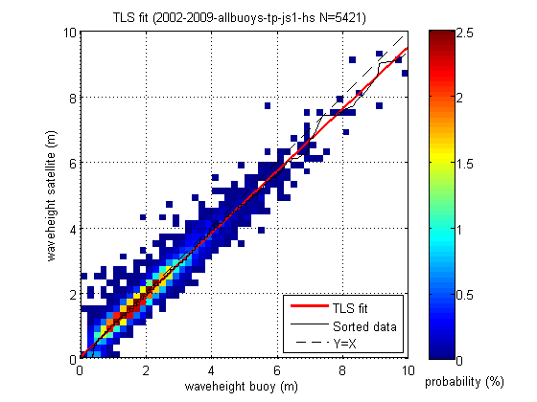
Figure 7a Least squares fit of raw wave height for Jason-1 altimeter and all buoys.
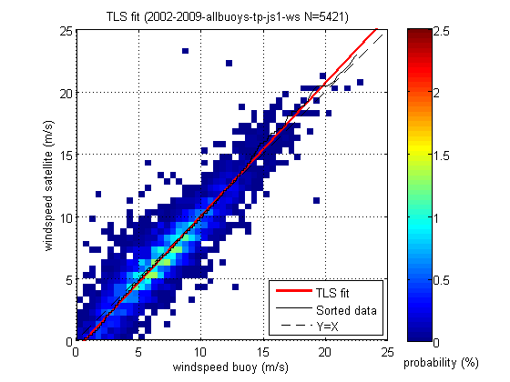
Figure 7b Least squares fit of raw wind speed for Jason-1 altimeter and all buoys.
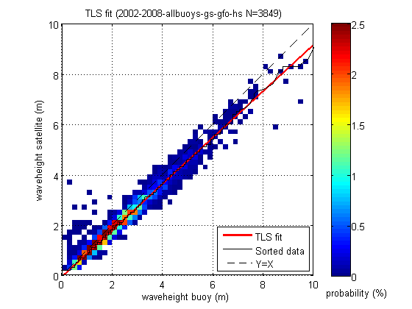
Figure 8a Least squares fit of raw wave height for GFO altimeter and all buoys.
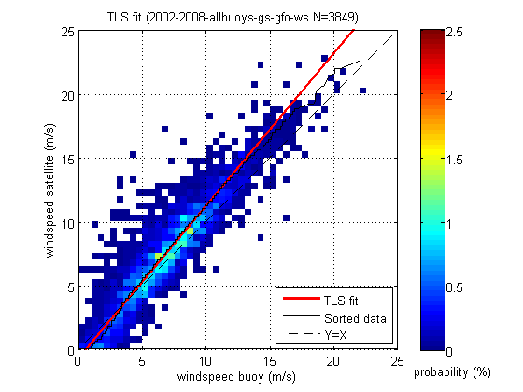
Figure 8b Least squares fit of raw wind speed for GFO altimeter and all buoys.
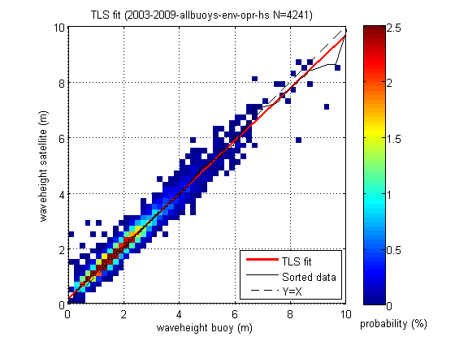
Figure 9a Least squares fit of raw wave height for Envisat altimeter and all buoys.
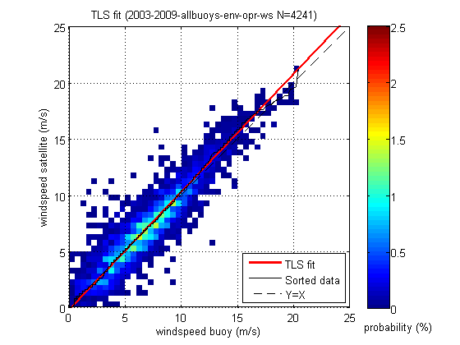
Figure 9b Least squares fit of raw wind speed for Envisat altimeter and all buoys.

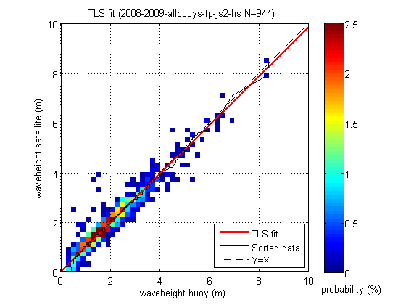
Figure 10a Least squares fit of raw wave height for Jason-2 altimeter and all buoys.
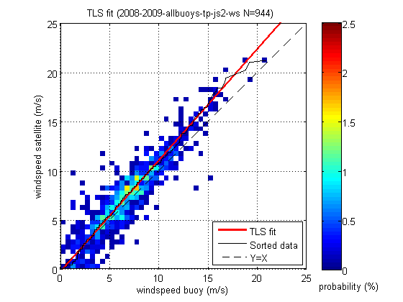
Figure 10b Least squares fit of raw wind speed for Jason-2 altimeter and all buoys.

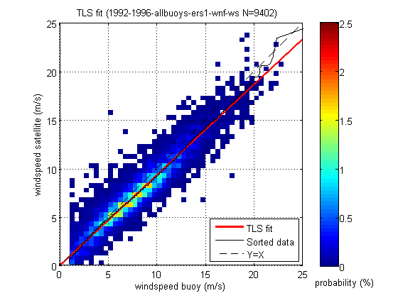
Figure 11a Least squares fit of raw wind speed for Ers-1 scatterometer and all buoys.
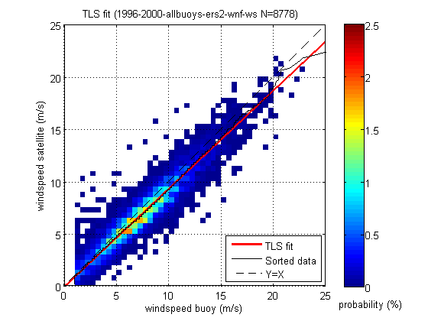
Figure 11b Least squares fit of raw wind speed for Ers-2 scatterometer and all buoys.

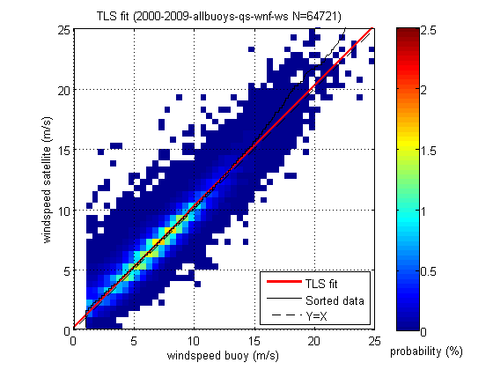
Figure 11c Least squares fit of raw wind speed for Quikscat scatterometer and all buoys.

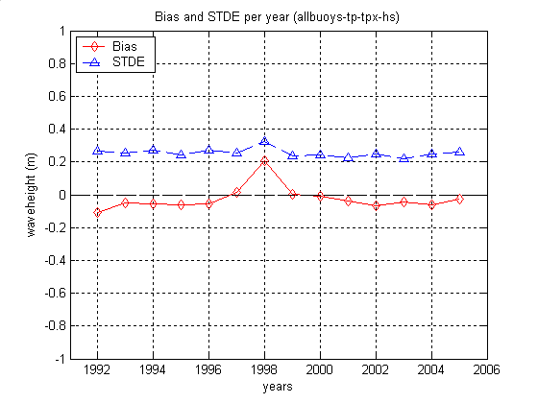
Figure 12a Bias and STD of error of raw wave height per year of Topex altimeter and all buoys.
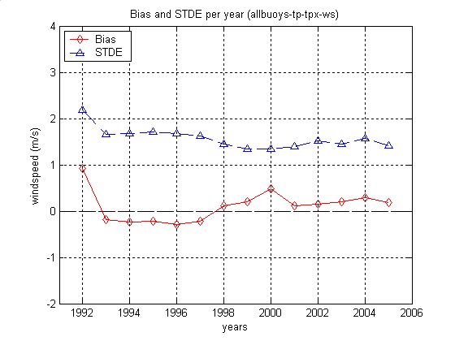
Figure 12b Bias and STD of error of raw wind speed per year of Topex altimeter and all buoys.
Figure 13a Bias and STD of error of raw wave height per year of Poseidon altimeter and all buoys (very few samples in 2001 and 2002).

Figure 13b Bias and STD of error of raw wind speed per year of Poseidon altimeter and all buoys (very few samples in 2001 and 2002).

Figure 14a Bias and STD of error of raw wave height per year of Geosat altimeter and all buoys.
Figure 14b Bias and STD of error of raw wind speed per year of Geosat altimeter and all buoys.
Figure 15a Bias and STD of error of raw wave height per year of Ers-1 altimeter and all buoys.
Figure 15b Bias and STD of error of raw wind speed per year of Ers-1 altimeter and all buoys.
Figure 16a Bias and STD of error of raw wave height per year of Ers-2 altimeter and all buoys.
Figure 16b Bias and STD of error of raw wind speed per year of Ers-2 altimeter and all buoys.
Figure 17a Bias and STD of error of raw wave height per year of Jason-1 altimeter and all buoys.
Figure 17b Bias and STD of error of raw wind speed per year of Jason-1 altimeter and all buoys.
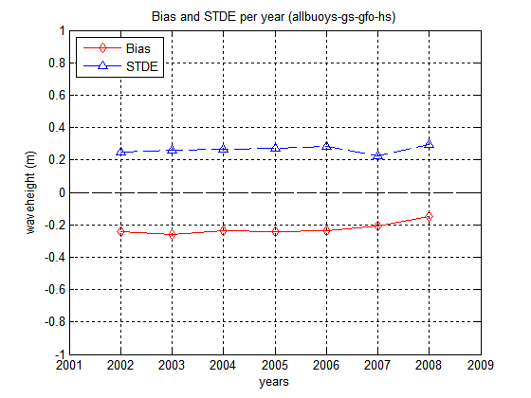
Figure 18a Bias and STD of error of raw wave height per year of GFO altimeter and all buoys.
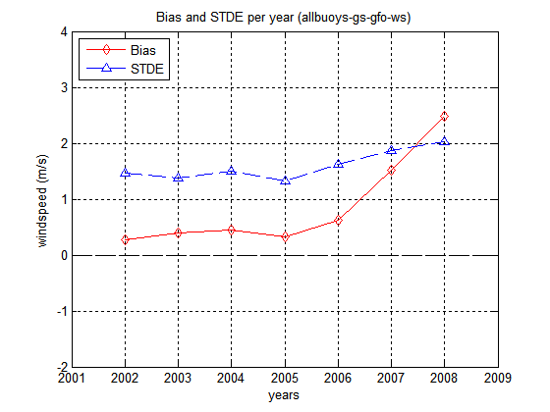
Figure 18b Bias and STD of error of raw wind speed per year of GFO altimeter and all buoys.

Figure 19a Bias and STD of error of raw wave height per year of Envisat altimeter and all buoys.
Figure 19b Bias and STD of error of raw wind speed per year of Envisat altimeter and all buoys.
Figure 20a Bias and STD of error of raw wave height per year of Jason-2 altimeter and all buoys.
Figure 20b Bias and STD of error of raw wind speed per year of Jason-2 altimeter and all buoys.
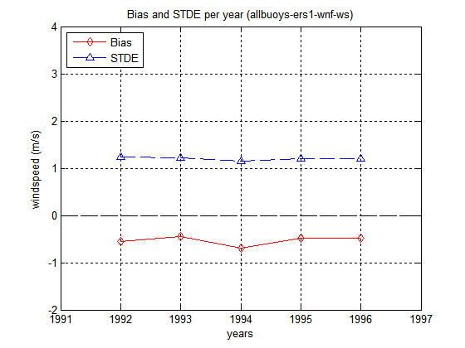
Figure 21a Bias and STD of error of raw wind speed per year of Ers-1 scatterometer and all buoys.
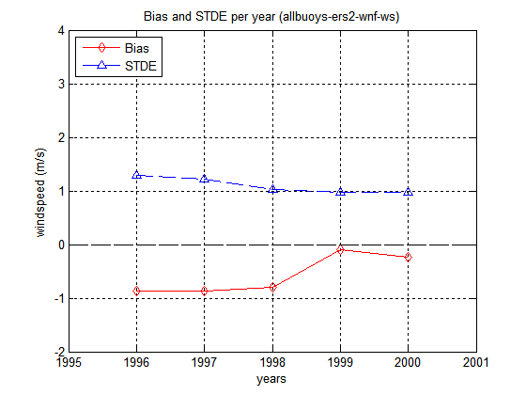
Figure 21b Bias and STD of error of raw wind speed per year of Ers-2 scatterometer and all buoys.

Figure 21c Bias and STD of error of raw wind speed per year of Quikscat scatterometer and all buoys.
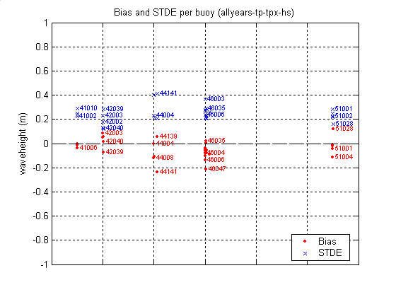
Figure 22a Bias and STD of error of raw wave height per buoy of Topex altimeter and all years.
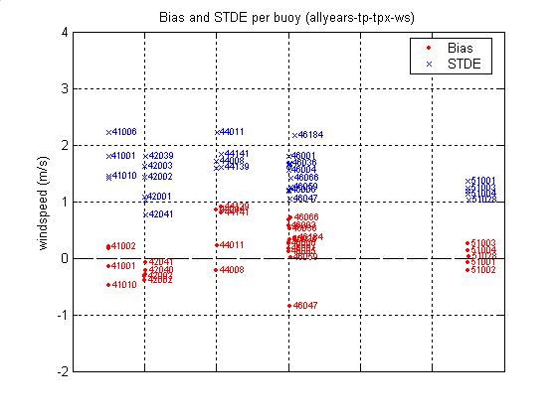
Figure 22b Bias and STD of error of raw wind speed per buoy of Topex altimeter and all years.
Figure 23a Bias and STD of error of raw wave height per buoy of Poseidon altimeter and all years.
Figure 23b Bias and STD of error of raw wind speed per buoy of Poseidon altimeter and all years.
Figure 24a Bias and STD of error of raw wave height per buoy of Geosat altimeter and all years.
Figure 24b Bias and STD of error of raw wind speed per buoy of Geosat altimeter and all years.
Figure 25a Bias and STD of error of raw wave height per buoy of Ers-1 altimeter and all years.
Figure 25b Bias and STD of error of raw wind speed per buoy of Ers-1 altimeter and all years.
Figure 26a Bias and STD of error of raw wave height per buoy of Ers-2 altimeter and all years.
Figure 26b Bias and STD of error of raw wind speed per buoy of Ers-2 altimeter and all years.
Figure 27a Bias and STD of error of raw wave height per buoy of Jason-1 altimeter and all years.
Figure 27b Bias and STD of error of raw wind speed per buoy of Jason-1 altimeter and all years.
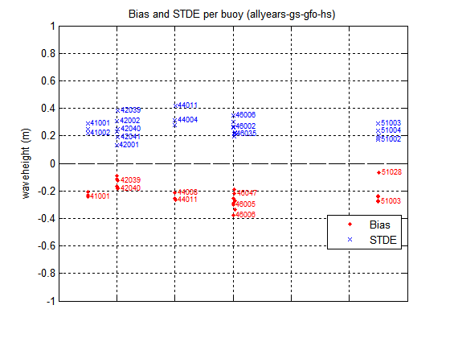
Figure 28a Bias and STD of error of raw wave height per buoy of GFO altimeter and all years.
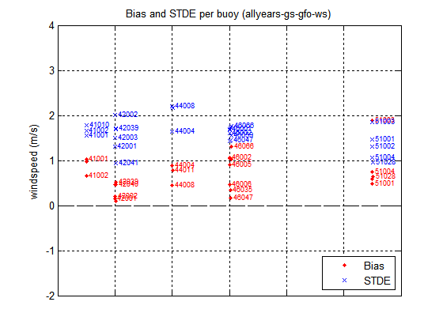
Figure 28b Bias and STD of error of raw wind speed per buoy of GFO altimeter and all years.
Figure 29a Bias and STD of error of raw wave height per buoy of Envisat altimeter and all years.
Figure 29b Bias and STD of error of raw wind speed per buoy of Envisat altimeter and all years.

Figure 30a Bias and STD of error of raw wave height per buoy of Jason-2 altimeter and all years.
Figure 30b Bias and STD of error of raw wind speed per buoy of Jason-2 altimeter and all years.

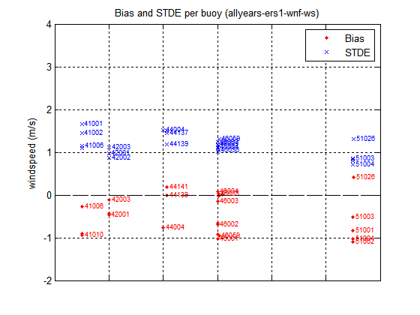
Figure 31a Bias and STD of error of raw wind speed per buoy of Ers-1 scatterometer and all years.
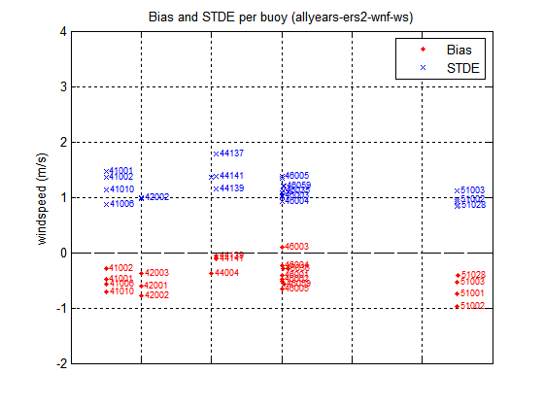
Figure 31b Bias and STD of error of raw wind speed per buoy of Ers-2 scatterometer and all years.

Figure 31c Bias and STD of error raw wind speed per buoy of Quikscat scatterometer and all years.

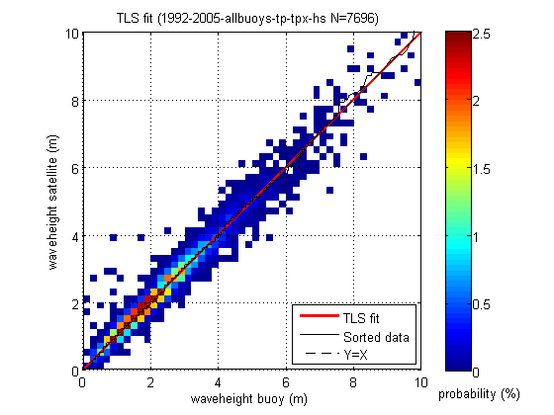
Figure 32a Least squares fit of corrected wave height for Topex altimeter and all buoys.
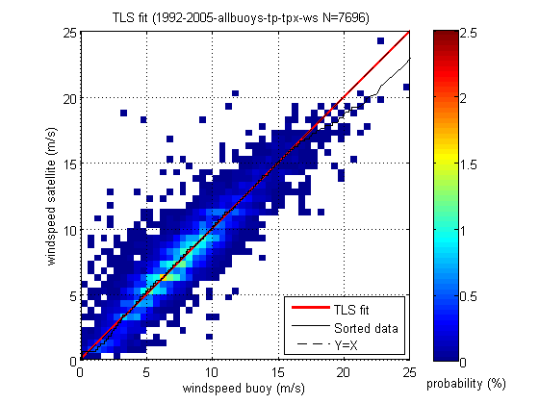
Figure 32b Least squares fit of corrected wind speed for Topex altimeter and all buoys.

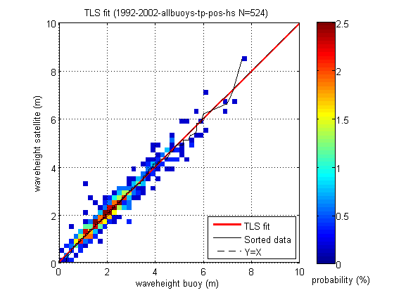
Figure 33a Least squares fit of corrected wave height for Poseidon altimeter and all buoys.
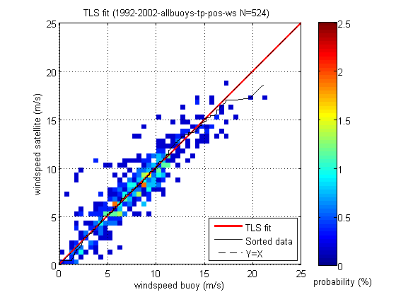
Figure 33b Least squares fit corrected wind speed for Poseidon altimeter and all buoys.
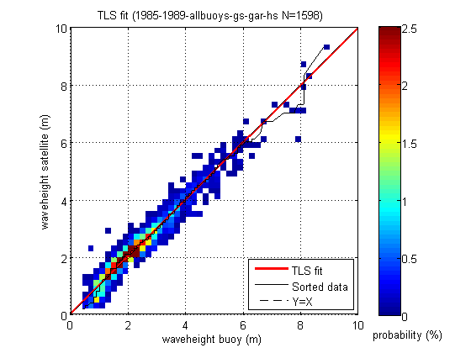
Figure 34a Least squares fit of corrected wave height for Geosat altimeter and all buoys.
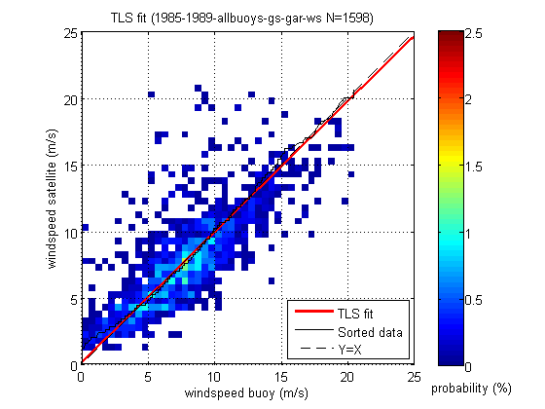
Figure 34b Least squares fit of corrected wind speed for Geosat altimeter and all buoys.
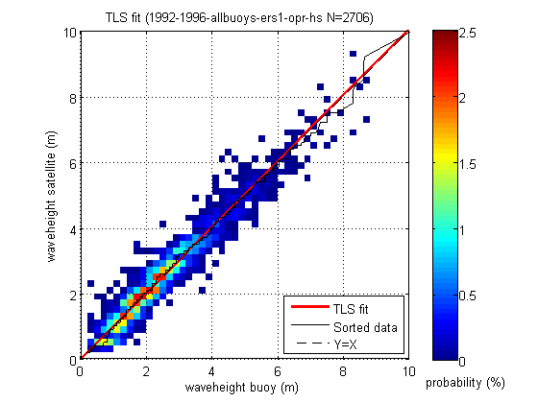
Figure 35a Least squares fit of corrected wave height for Ers-1 altimeter and all buoys.
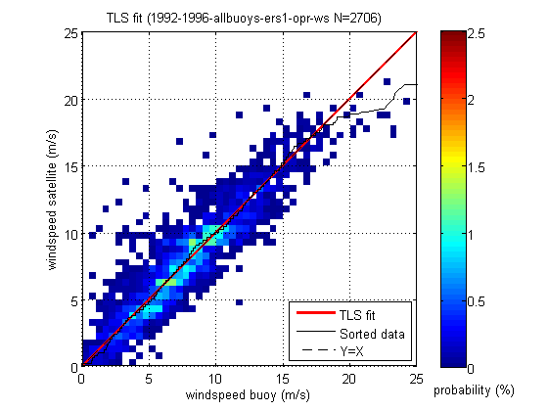
Figure 35b Least squares fit of corrected wind speed for Ers-1 altimeter and all buoys.
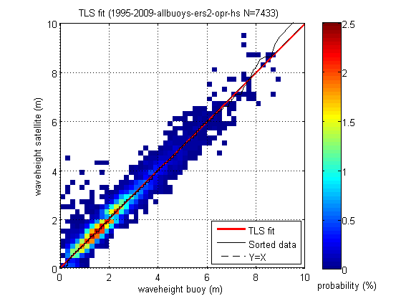
Figure 36a Least squares fit of corrected wave height for Ers-2 altimeter and all buoys.
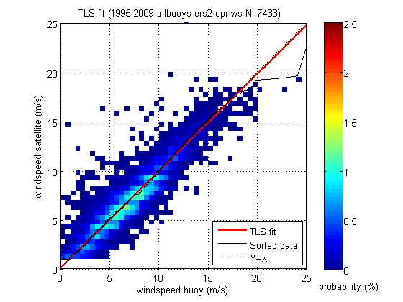
Figure 36b Least squares fit of corrected wind speed for Ers-2 altimeter and all buoys.
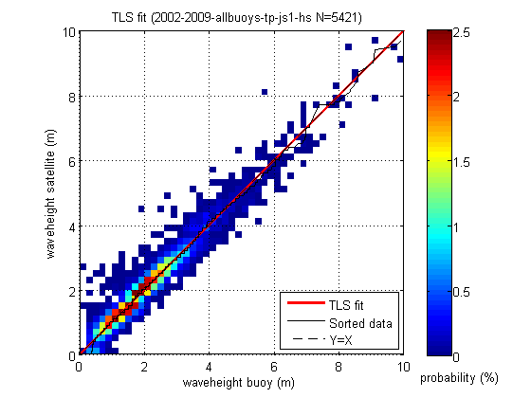
Figure 37a Least squares fit of corrected wave height for Jason-1 altimeter and all buoys.
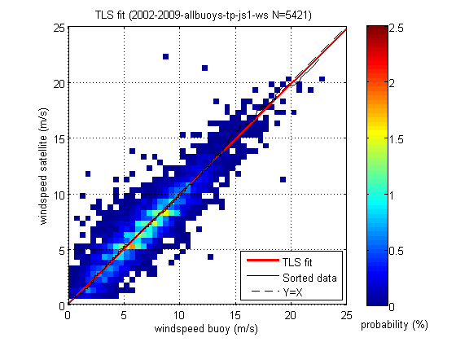
Figure 37b Least squares fit of corrected wind speed for Jason-1 altimeter and all buoys.
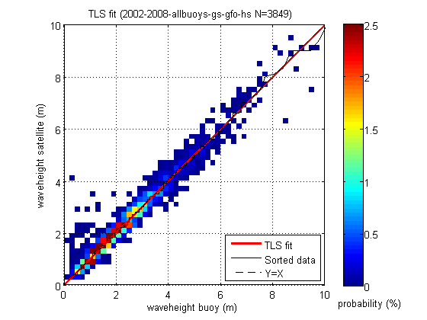
Figure 38a Least squares fit of corrected wave height for GFO altimeter and all buoys.
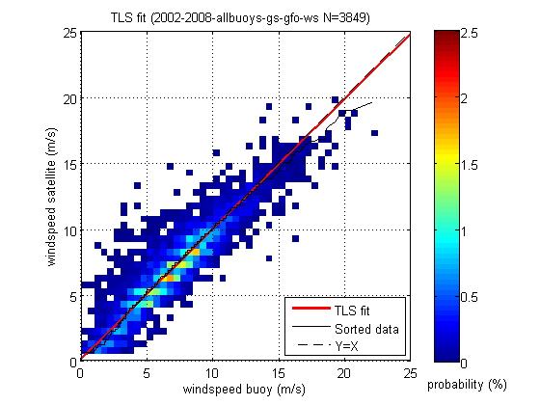
Figure 38b Least squares fit of corrected wind speed for GFO altimeter and all buoys.
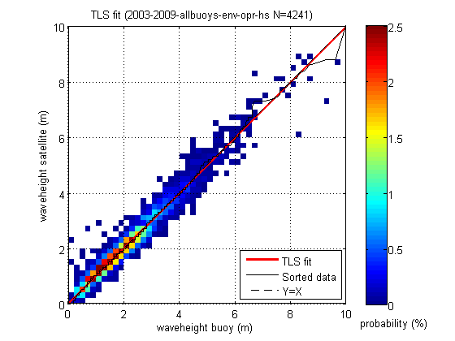
Figure 39a Least squares fit of corrected wave height for Envisat altimeter and all buoys.
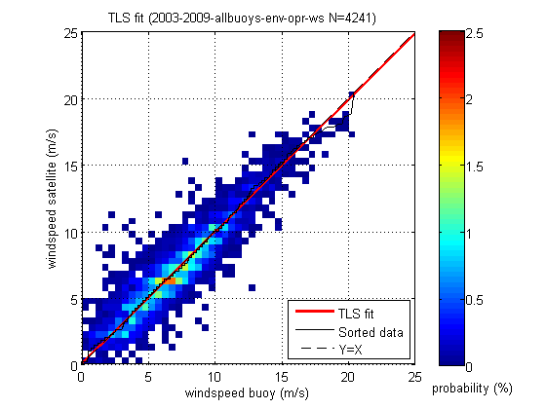
Figure 39b Least squares fit of corrected wind speed for Envisat altimeter and all buoys.
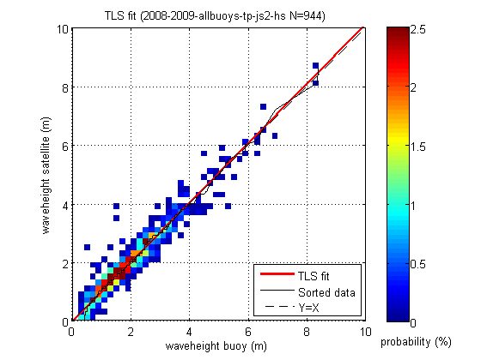
Figure 40a Least squares fit of corrected wave height for Jason-2 altimeter and all buoys.
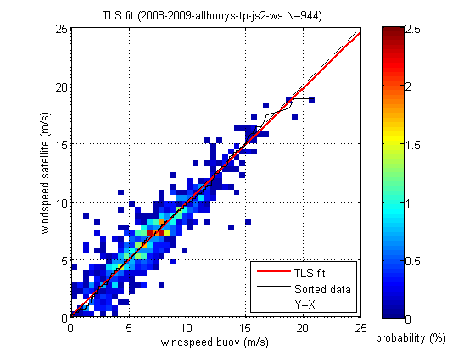
Figure 40b Least squares fit of corrected wind speed for Jason-2 altimeter and all buoys.

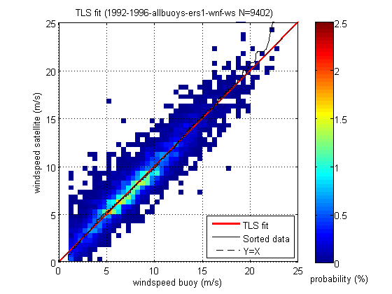
Figure 41a Least squares fit of corrected wind speed for Ers-1 scatterometer and all buoys.
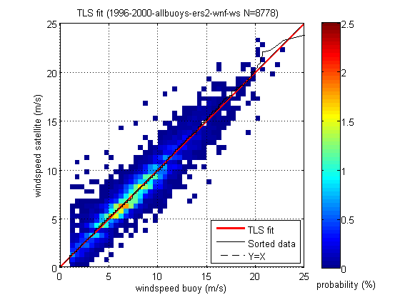
Figure 41b Least squares fit of corrected wind speed for Ers-2 scatterometer and all buoys.
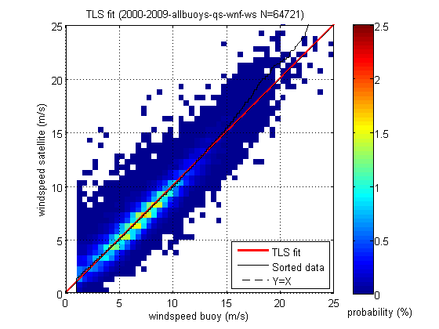
Figure 41c Least squares fit of corrected wind speed for Quikscat scatterometer and all buoys.

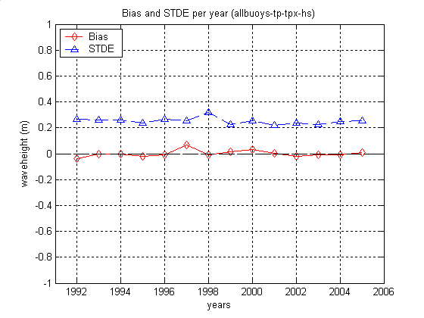
Figure 42a Bias and STD of error of corrected wave height per year of Topex altimeter and all buoys.
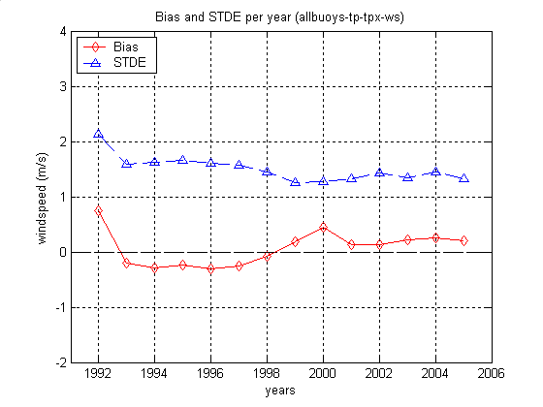
Figure 42b Bias and STD of error of corrected wind speed per year of Topex altimeter and all buoys.
Figure 43a Bias and STD of error of corrected wave height per year of Poseidon altimeter and all buoys (very few samples in 2001 and 2002).

Figure 43b Bias and STD of error of corrected winspeed per year of Poseidon altimeter and all buoys (very few samples in 2001 and 2002).

Figure 44a Bias and STD of error corrected wave height per year of Geosat altimeter and all buoys.
Figure 44b Bias and STD of error of corrected wind speed per year of Geosat altimeter and all buoys.
Figure 45a Bias and STD of error of corrected wave height per year of Ers-1 altimeter and all buoys.
Figure 45b Bias and STD of error of corrected wind speed per year of Ers-1 altimeter and all buoys.
Figure 46a Bias and STD of error of corrected wave height per year of Ers-2 altimeter and all buoys.
Figure 46b Bias and STD of error of corrected wind speed per year of Ers-2 altimeter and all buoys.
Figure 47a Bias and STD of error of corrected wave height per year of Jason-1 altimeter and all buoys.
Figure 47b Bias and STD of error of corrected wind speed per year of Jason-1 altimeter and all buoys.
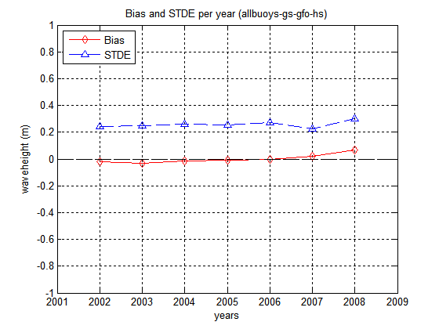
Figure 48a Bias and STD of error of corrected wave height per year of GFO altimeter and all buoys.
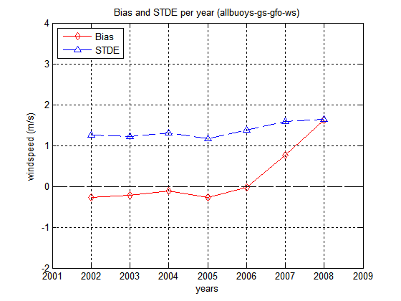
Figure 48b Bias and STD of error of corrected wind speed per year of GFO altimeter and all buoys.
Figure 49a Bias and STD of error of corrected wave height per year of Envisat altimeter and all buoys.

Figure 49b Bias and STD of error of corrected wind speed per year of Envisat altimeter and all buoys.
Figure 50a Bias and STD of error of corrected wave height per year of Jason-2 altimeter and all buoys.
Figure 50b Bias and STD of error of corrected wind speed per year of Jason-2 altimeter and all buoys.

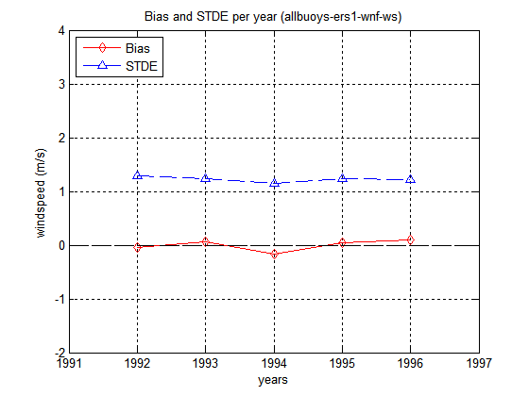
Figure 51a Bias and STD of error corrected wind speed per year of Ers-1 scatterometer all buoys.
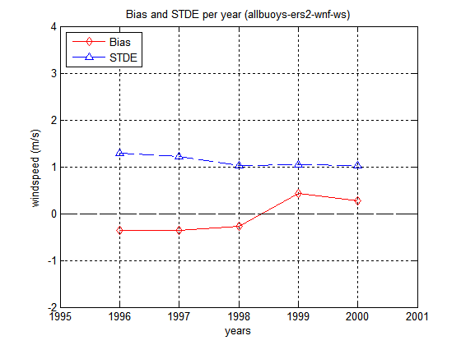
Figure 51b Bias and STD of error corrected wind speed per year of Ers-2 scatterometer all buoys.
Figure 51c Bias and STD of error corrected wind speed per year of Quikscat scatterometer all buoys.
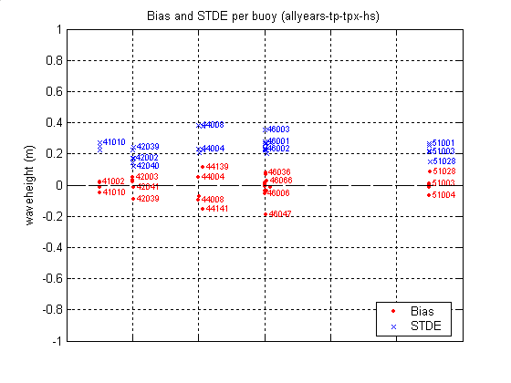
Figure 52a Bias and STD of error of corrected wave height per buoy of Topex altimeter and all years.
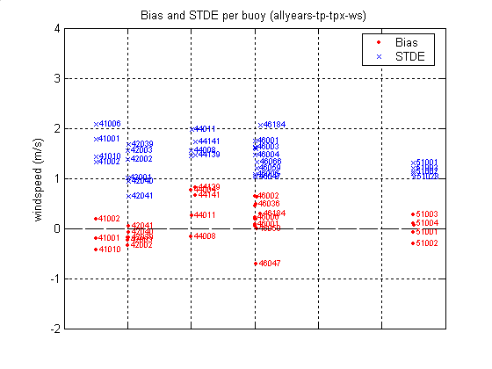
Figure 62b Bias and STD of error of corrected wind speed per buoy of Topex altimeter and all years.
Figure 53a Bias and STD of error corrected wave height per buoy of Poseidon altimeter all years.
Figure 53b Bias and STD of error corrected wind speed per buoy of Poseidon altimeter and all years.
Figure 54a Bias and STD of error corrected wave height per buoy of Geosat altimeter and all years.
Figure 54b Bias and STD of error of corrected wind speed per buoy of Geosat altimeter and all years.
Figure 55a Bias and STD of error of corrected wave height per buoy of Ers-1 altimeter and all years.
Figure 55b Bias and STD of error of corrected wind speed per buoy of Ers-1 altimeter and all years.
Figure 56a Bias and STD of error of corrected wave height per buoy of Ers-2 altimeter and all years.
Figure 56b Bias and STD of error of corrected wind speed per buoy of Ers-2 altimeter and all years.
Figure 57a Bias and STD of error corrected wave height per buoy of Jason-1 altimeter and all years.
Figure 57b Bias and STD of error corrected wind speed per buoy of Jason-1 altimeter and all years.
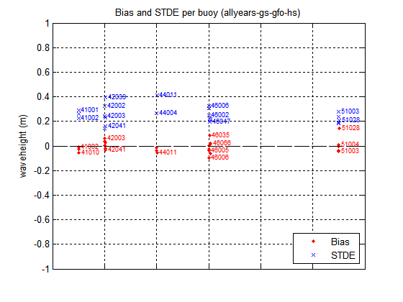
Figure 58a Bias and STD of error of corrected wave height per buoy of GFO altimeter and all years.
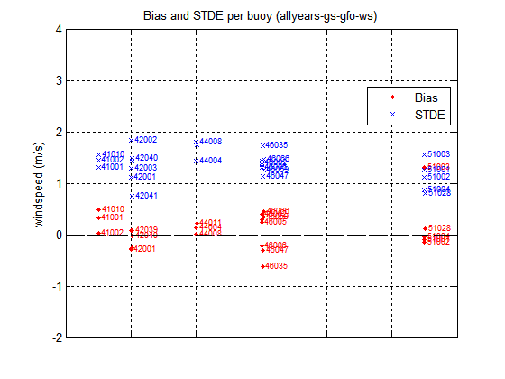
Figure 58b Bias and STD of error of corrected wind speed per buoy of GFO altimeter and all years.
Figure 59a Bias and STD of error corrected wave height per buoy of Envisat altimeter and all years.
Figure 59b Bias and STD of error of corrected wind speed per buoy of Envisat altimeter and all years.
Figure 60a Bias and STD of error corrected wave height per buoy of Jason-2 altimeter and all years.
Figure 60b Bias and STD of error corrected wind speed per buoy of Jason-2 altimeter and all years.

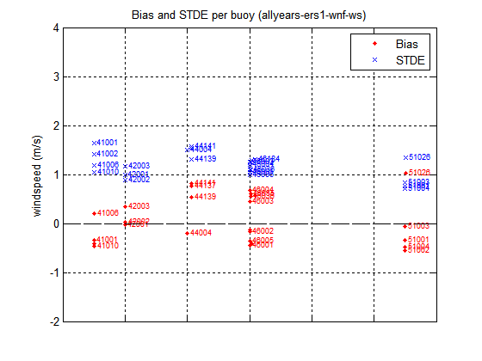
Figure 61a Bias and STD of error corrected wind speed per buoy of Ers-1 scatterometer all years.
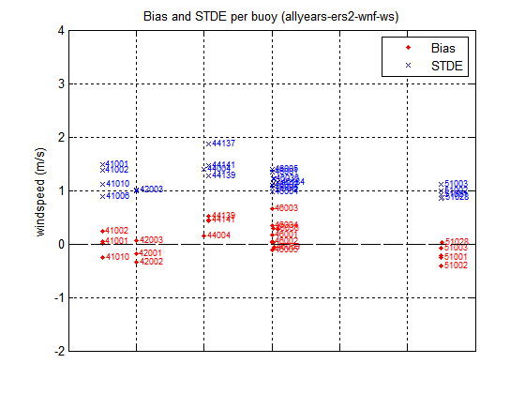
Figure 61b Bias and STD of error corrected wind speed per buoy of Ers-2 scatterometer all years.

Figure 61c Bias and STD of error corrected wind speed per buoy of Quickscat scatterometer all years.

