
Advisory and Research Group on
Geo Observation Systems and Services

Nearshore waveclimate

Methods and validation of the nearshore branch of waveclimate.com

January 2004

Nearshore waveclimate

P. Groenewoud, C.F. de Valk - ARGOSS
G. Klopman - Albatros Flow Research


Advisory and Research Group on
Geo Observation Systems and Services

1 Introduction 1
2 Method 2
2.1 Sheltering of wave directions by islands, capes and land 2
2.2 Refraction of waves by varying bathymetry 2
2.3 Wave shoaling due to changing water depth 3
2.4 Bottom friction 4
2.5 Wave breaking 4
2.6 Overview of the nearshore wave computation 5
3 Validation 7
3.1 Duck Beach 7
3.1.1 Situation 7
3.1.2 Comparison nearshore 10
3.1.3 Offshore to nearshore transition 11
3.1.4 Comparison offshore 12
3.2 Sheltering test off California 13
3.2.1 Situation 13
3.2.2 Offshore climate 16
3.2.3 Nearshore climate 17
3.3 A partially sheltered site on the west coast of Chile 18
3.3.1 Situation 18
3.3.2 Offshore climate 21
3.3.3 Nearshore climate 23
3.4 Bottom friction test in the Arabian Gulf 24
3.4.1 Situation 24
3.4.2 Results of the waveclimate.com model 27
3.4.3 Comparison to SWAN wave model results 28
3.5 Conclusions 31
Appendices 32
Appendix 1 Scatter tables Duck Beach 33
Nearshore waveclimate 33
Appendix 2 Scatter tables California 35
Offshore waveclimate 35
Nearshore waveclimate 41
Appendix 3 Scatter tables Chile 43
Offshore waveclimate 43
Nearshore waveclimate based on SAR spectra 47
Nearshore waveclimate based on wave model spectra 51
Appendix 4 Scatter tables Arabian Gulf 53
Offshore waveclimate 53
Nearshore waveclimate ignoring bottom friction 55
Nearshore wave climate taking bottom friction into account 57

Introduction

In the transition from deep to shallow water profound changes in the wave climate may occur. However, for most nearshore locations no wave observations are available. Since there is a fair amount of knowledge about the physical processes occurring during the propagation of waves to the shore, we use a numerical wave model to determine the nearshore climate from the offshore climate.

The physical processes transforming waves when they approach the shore are:

- Sheltering of certain wave directions by island and capes,
- Refraction of waves by varying bathymetry,
- Wave shoaling due to changing water depth,
- Wave breaking due to the limited water depth or steepness of waves in deep water,

- Local fetch-limited wind-induced wave growth,
- Diffraction by islands, capes and shoals,
- Non-linear wave interactions above shoals and reefs, introducing wave period changes,
- Current refraction by tidal flows and rivers,
- Bottom friction.

In most circumstances the first four processes are the dominant ones, so these are currently modeled in the nearshore waveclimate.com branch.

The user selects the nearshore site where the wave climate is to be estimated and an offshore area or wave model gridpoint where the input data are collected. The wave spectra from this offshore area / gridpoint are assumed to be representative for the unsheltered deep-water conditions which directly affect the climate at the selected nearshore site. Therefore the offshore area / gridpoint should be chosen with care.

In chapter 2, the modelling of the first four processes mentioned above is described. Validation of the model is presented in chapter 3.

Method

Sheltering of wave directions by islands, capes and land

Not every offshore wave can reach the nearshore location, simply because it is blocked by islands, capes and other land masses. From a world-wide database of coastlines we determine the sheltered offshore wave directions for the given nearshore location.

The user has some control over the sheltered directions by zooming in or out on the displayed nearshore map: the sheltered wave directions are determined from the coastlines that are visible in the displayed nearshore map. Optionally, the user can specify an unsheltered directional sector to override the default.. From the coastline, a first guess of the coastal normal is provided which can be modified by the user.

It is assumed that the nearshore site is only exposed to waves coming from a 180º sector centred around the coastal normal.

In the case of a slightly curving coastline, distant swell from directions considered sheltered may still reach the nearshore location when being trapped by the nearshore bathymetry or by diffraction. These subtle effects are not incorporated in the model but by choosing the offshore area from which the measurements are obtained close enough to the nearshore location, these effects are already in-part included into the offshore observations. Of course there is a compromise to be made as reducing the size of the offshore area will leave fewer satellite observations. Alternatively or in addition, wave model data retrieved from an offshore wave model point can be used.

The wave direction sectors from which waves can reach the nearshore site are shown shaded in the nearshore maps: they are called “unsheltered directions”.

Refraction of waves by varying bathymetry

Refraction due to the sloping seabed is modelled by assuming parallel depth contours perpendicular to the coastal normal (see 2.1). Snel's Law is used to transform the deep water wave directions to the nearshore site:

$k_{n}\text{sin} \left(θ_{n} − θ_{c}\right) = k_{o}\text{sin} \left(θ_{o} − θ_{c}\right)$,

where $k_{n} = 2π / λ_{n}$ is the nearshore wave number ( $λ_{n}$is the nearshore spectral wave length), $θ_{n}$ is the nearshore wave direction, $θ_{c}$ is the coastal normal, $k_{o}$ is the offshore wave number and $θ_{o}$ is the offshore wave direction.

Refraction of waves
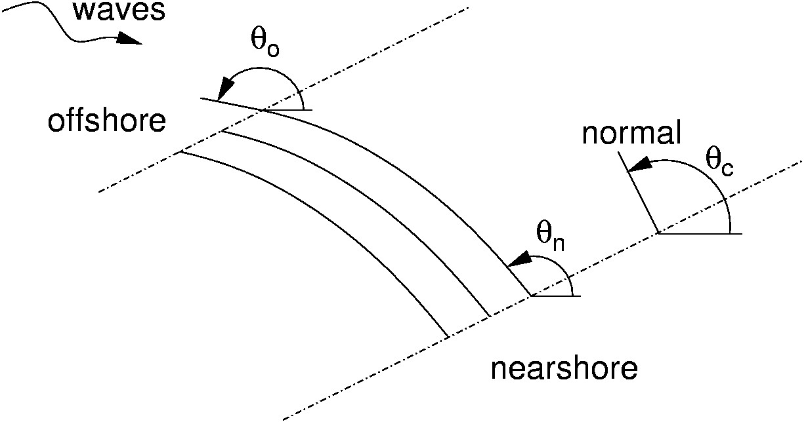

The nearshore and offshore wave numbers k are determined from the angular frequency $ω$ and water depth d through the wave dispersion relationship:

$ω^{2} = g k \text{tanh} \text{kd}$,

with g the gravitational acceleration.

The nearshore water depth is determined from the seabed elevation and mean surface elevation at the nearshore location as specified by the user. The offshore water depth is assumed to be infinite.

Due to refraction, the direction of wave propagation tends toward the coastal normal when waves approach the shore, and eventually little wave energy will be found in propagation directions parallel to the shore. To estimate tidal effects, the user can assess the nearshore wave climate for different values of the mean surface elevation such as MWL, HWL and LWL and combine the results.

Wave shoaling due to changing water depth

Wave shoaling in shallow water is the result of changes in the group velocity c_{g} of the waves, which is the velocity at which the wave energy propagates;

$c_{g} = \frac{1}{2} \frac{ω}{k} \left(1 + \text{kd} \frac{1 − {\text{tanh}}^{2} \text{kd}}{\text{tanh} \text{kd}}\right)$,

Most often the group velocity decreases toward the shore (neglecting breaking for the moment). Under the assumption that the component of the offshore group velocity parallel to the coastline is uniform, the invariance of the energy flux E c_{g} perpendicular to the coast dictates that the energy density E will increase with a factor

$\frac{c_{g,o}\text{cos} \left(θ_{o} − θ_{c}\right)}{c_{g,n}\text{cos} \left(θ_{n} − θ_{c}\right)}$

where $c_{g,o}$ is the offshore group velocity, and $c_{g,n}$ is the nearshore group velocity respectively, $θ_{o}$ is the offshore wave direction, $θ_{n}$ is the nearshore wave direction and $θ_{c}$ is the coastal normal.

Bottom friction

Bottom friction is caused by the orbital velocity of water particles near the bottom. Basically, the dissipation due to bottom friction is given by:

$$S_{f}(k)=−C_{f}\frac{k}{\text{sinh}2\text{kd}}E(k)$$

where k is the nearshore spectral wavenumber, d is water depth, E(k) is the energy density and C_{f} is the frictional dissipation coefficient depending on the seabed roughness and on the sea state (mean square orbital velocity near the seabed). Typically C_{f} ranges from 0.001-0.01 m/s. In our offshore-to-nearshore transformation we have set C_{f} equal to 0.008 m/s as recommended for not too extreme conditions by Weber (1994). We have fixed C_{f} because in the vast majority of foreseen applications, the information needed to improve the estimate (such as local offshore and nearshore wave measurements) is not available, and because it is only warranted in a comprehensive and detailed modelling study.

An idea of the sensitivity of the nearshore climate to bottom friction can be obtained by assessing the climate with and without bottom friction, and possibly with a perturbed depth profile.

The user of waveclimate.com is asked to specify a seabed profile along the seaward normal if bottom friction is switched on. This profile is given in terms of distances to the coast and related water depths.
According to the above formulation, contributions to the total bottom friction are found for each trajectory between the given contour lines. Contributions are weighed with the length of each trajectory. As for shoaling, only the wave component perpendicular to the coastline is taken into account for bottom friction.

Wave breaking

The maximum wave height in shallow water is limited by the fact that the waves break when they either become too steep, or too high as compared to the shallow water depth. Whereas the preceding description of wave sheltering, refraction and shoaling applies to every single wave component with a particular frequency and propagation direction, wave breaking is a nonlinear process in which different wave components interact.

With this in mind, wave breaking is accounted for by limiting the (shoaled) significant wave height in shallow water to the value (an adapted Miche criterium)

$H_{\text{max}} = \frac{ε}{k_{n}} \text{tanh} \frac{γ {\bar{k}}_{n} d}{ε}$,

with $ε = 2π ⋅ 0\text{.}\text{055}$ the maximum wave steepness and $γ = 0\text{.}\text{55}$ the breaker index for shallow water. ${\bar{k}}_{n}$is a mean wavenumber obtained from the nearshore spectral mean wave period $T_{m0,−1}$ by the dispersion relationship. To avoid unrealistically strong interaction between the broad short-wave wind-sea peak and the narrow long-wave swell preak, the shallow-water wave height limitation is applied separately to wind-sea and swell.

Overview of the nearshore wave computation

The procedure for determining nearshore wave climate starts from the individual observations of offshore wave spectra. The transformation to nearshore wave conditions comprises the following steps:

- Wave spectra (either observed SAR spectra inside the specified offshore area or computed wave model spectra from a model gridpoint specified by the user) are retrieved from the database of waveclimate.com. These are stored as nondirectional spectral density and mean propagation direction as a function of frequency. Using the stored wind-sea wave age and wind speed, the spectrum is split into a wind-sea and a swell spectrum.

- The significant wave heights integrated from the offshore wave spectra are calibrated against radar altimeter wave height measurements obtained in the same area (please refer to waveclimate.com>Help>Detailed validation report>Chapter 4.2/5.2 Calibration of SAR data/Calibration of wave model data). We use the wave height calibration factors derived for wind-sea and swell to calibrate the wind-sea and swell energy spectra respectively. Note that wave model results are calibrated with altimeter wave height retrieved from the offshore data area . As a result, the size of the offshore data area influences the nearshore results based on (calibrated) offshore wave model spectra.

- Two-dimensional offshore wind-sea and swell spectra on a frequency/direction grid are reconstructed assuming a cosine-squared directional distribution. For swell, a narrower distribution is used than for wind-sea.

- Nearshore spectral moments of wind-sea and swell are found by applying sheltering (see paragraph 2.1), refraction (paragraph 2.2), shoaling (paragraph 2.3) and dissipation due to bottom friction (paragraph 2.4) separately to the two-dimensional spectra of offshore wind-sea and swell. These moments are $m_{0}$, $m_{−1,0}$ , $m_{0,2}$ and the first-order circular moments.

- From these moments, the (unbroken) significant wave height, mean and zero-crossing period and mean direction are computed.

- The significant wave height limitation due to wave breaking (see paragraph 2.5) is applied separately for wind-sea and swell. Spectral shapes of wind-sea and swell are assumed to remain unaffected.

- Moments for the total nearshore sea state (wind-sea and swell combined) are computed from the moments of the wind-sea and swell spectra and converted to overall nearshore significant wave height, mean and zero-crossing period and propagation direction.

The computed nearshore wave parameters are used to assess the nearshore wave climate in (almost) exactly the same manner as is done for the offshore climate. In deep water, without sheltering by islands and capes, nearshore and offshore waveclimate will be identical except for differences due to

- The assumption that the nearshore site is only exposed to waves coming from a 180º sector centred around the coastal normal

- The fact that nearshore parameters are integrated from two-dimensional spectra assuming a cosine-squared directional distribution where as offshore parameters are integrated from one-dimensional energy spectra and mean direction.

Please note that using the above spectral approach, nearshore waves can (occassionally) seem to come from directions sheltered by islands or capes. If the nearshore site is situated behind an island, offshore wave can come from both sides of the island. This can lead to double peaked nearshore spectra. As a result, nearshore mean wave direction will be in between the unsheltered directions. Please refer to the sheltering test off California for an example of nearshore waves that appear to come from sheltered directions.

Validation

The nearshore waveclimate is derived from either offshore SAR spectra (observed in the chosen offshore data area) or from wave model spectra (computed at the selected offshore gridpoint).

In this document, offshore wave model computations cover the years 1998-2002 and SAR spectra cover the period 1993-2002.

Duck Beach

Situation

We used two buoys at the east coast of the United States (“Duck Beach”) to validate the nearshore wave transformation. The selected offshore area (from which the SAR wave spectra are taken) and the nearshore location are depicted below.

Offshore area (200km) around (36˚10’N,75˚00’W) on the Atlantic to the east of the US.
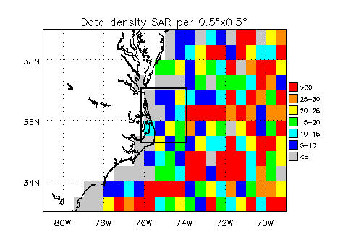

Nearshore location on the east coast of the US (36˚11’14’’N,75˚44’22’’W) with seaward normal at 70˚ and 8m water depth.
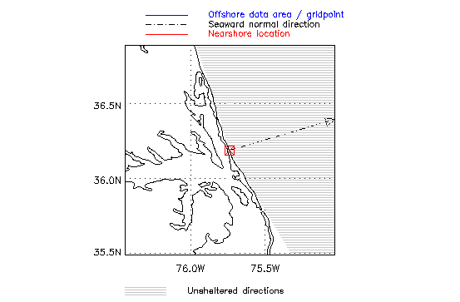

We validated statistics of nearshore wave parameters computed by waveclimate.com (based on observed SAR spectra as well as on computed wave model spectra) against statistics of nearshore directional wave measurements from the so-called 8 Meter Array of the Field Research Facility at Duck Beach. The nearshore location used in waveclimate.com comes close to the centre of the 8 Meter Array at (36˚11’14.06’’N, 75˚44’34.39’’W), about 1 km from the shoreline. The selected coastal normal direction of 70 degrees is taken from the situation sketch and depth contour map below.

Situation sketch near the Field Research Facility (FRF)
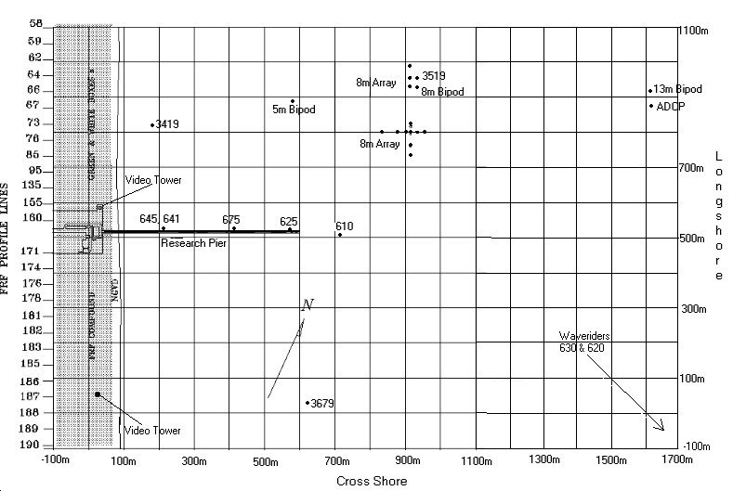

Depth contours are almost parallel to the coast line as seen from the depth contour map below, so the bathymetry matches model assumptions well.

Depth contour map near FRF
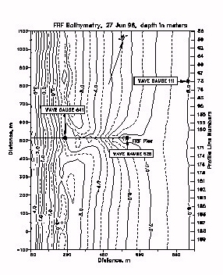

Comparison nearshore

The plots below show the comparison of the (directional) distribution of wave height as observed by the array versus the nearshore wave climate from waveclimate.com. Waveclimate.com results are based on either observed SAR spectra or wave model spectra (see scatter tables in Appendix 1 for details).

The distribution of wave height as well as the directional distribution based on satellite observations from waveclimate.com and the climate from local data are seen to agree closely. Taking the wave model as offshore data source decreases the nearshore results somewhat. Waveclimate.com gives slightly lower probabilities of low wave heights in the classes 0.0-0.5m and 0.5-1m and overestimates slightly the occurrence of higher waves.

Offshore to nearshore transition

This paragraph compares the nearshore data to data at different distances offshore both from in-situ and from satellite measurements, to illustrate the consistency between the different data sources.

There is another buoy available at FRF: waverider buoy 630 indicated by the arrow in the lower right corner of the situation sketch above. This waverider lies about 4 km offshore at position (36˚10’4.23’’N, 75˚42’2.40’’W) in water of about 17 m deep. The center of the 200 km wide offshore area chosen in waveclimate.com (36˚10’N, 75˚00’W) lies a bit to the east of this wave rider in order to avoid too much land inside the area and to make sure to have enough SAR offshore samples (we want at least 100 samples). We did not select a larger offshore data area (400 km or 500 km) around the waverider buoy because we wanted the offshore climate to be as close to the climate measured by the buoy as possible. The plot below compares distributions of observed and computed wave height, both nearshore and at different distances offshore:

- 8m Array- nearshore observations with 8m waterdepth
- SAR nearshore- nearshore model computations based on offshore SAR spectra
- Wave rider- wave rider buoy 630 at about 4km offshore and 17m depth
- ALT offshore 50km- offshore computations based on Altimeter samples from a 50 km wide area around (36˚10’N, 75˚42’W)
- SAR offshore 200 km- offshore computations based on SAR samples from a 200 km wide area around (36˚10’N, 75˚00’W)

From the plot above we see that the wave rider is too close to the shore to be comparable to results from the offshore area of waveclimate.com. The shape of the wave height distributions of the 8 m array nearshore and the wave rider buoy are similar due to the small distance of about 3 km in between. Indeed, taking a smaller offshore area around the wave rider brings the offshore computations closer to the wave rider observations, as expected.

The offshore to nearshore transition of wave height becomes clear when looking at the probability distributions in the order: SAR 200km - ALT 50 km - Wave rider - SAR nearshore - 8m Array.

Comparison offshore

Fortunately, there is a NDBC buoy is in the neighbourhood to check the offshore climate used in waveclimate.com. This NDBC buoy 44014 is located at 64 NM east of Virginia Beach at (36°34'59"N 74°50'24"W), to the northeast of Duck Beach. We selected an offshore area around (36˚35’N, 74˚50’W) and a model output point at (37°N,75°W) in waveclimate.com to produce wave heights comparable to the buoy observations. The probability distributions of wave height based on offshore SAR samples from a 200 km wide area, of wave height based on Altimeter samples from a 50 km area around the buoy, of wave heights from the wave model output point and from the buoy itself are compared below:

Sheltering test off California

Situation

For a case study of sheltering, we selected two NOAA buoys on the Pacific to the north-west of Los Angeles: ndbc_46053 (Santa Barb E; 12NM Southwest of San Barbara; 417 m waterdepth) at (34˚14’10’’N, 119˚,51’00’’W) as representative for the nearshore climate and station ndbc_46063 (Pt.Conception; 50NM West of Santa Barbara ; 598m waterdepth) at (34˚15’03’’N, 120˚,39’53’’W) for comparison offshore.

Offshore area (500km) around (33˚30’N,120˚30’W) on the Pacific to the west of the US.
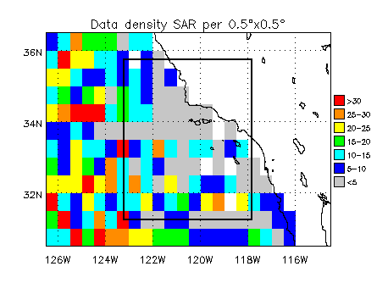

Selected wave model gridpoint (35° 00'N,122° 30'W).
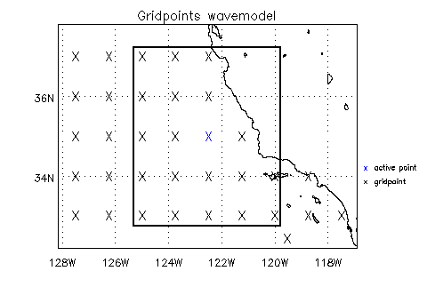

Nearshore location of buoy ndbc_46053 on the west coast of the US at (34˚14’10’’N,119˚51’00’’W) with seaward normal at 205˚ and 417m water depth.

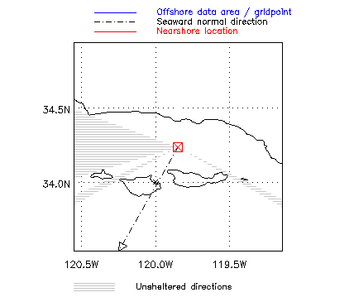

Offshore climate

Below, the offshore wave height distributions from SAR data, altimeter data and data from the offshore buoy ndbc_46063 are shown. They agree reasonably well.

From the scatter tables based on the SAR samples in Appendix 2, we see that the offshore wave climate is governed by waves from west and north-west. Wind-sea waves of about 1 m come mainly from north-west. The highest swell waves of 2 m or so come from north-west and lower swells come from west and south-west.

The scatter tables based on the wave model computations in Appendix 2 also (just as the SAR-based results) show waves mainly coming from the north-west. Lower swell from the south-west , as present in the SAR tables, is not found here. In addition, waves from the north and from the west are somewhat higher. This is probably caused by the fact that SAR observations come from a larger area and therefore contain more spatial variability. The lower swell from the south-west most likely occurs in the south-west corner of the offshore data area used to select SAR samples.

Nearshore climate

Below, the nearshore wave height distribution derived from SAR and wave model data in waveclimate.com is plotted together with the distribution of wave height observed by the nearshore buoy ndbc_46053.

The overall agreement is fair, although waveclimate.com underestimates the wave height in the range of 0 to 2.5 m. Possibly this underestimation is caused by the fact that we did not implement diffraction (yet). According to the scatter tables below, waves nearshore come from the west as expected based on sheltering. Offshore (swell) waves from north-west are sheltered.

The related scatter tables can be found in Appendix 2.

Occasionally, scatter tables of wave height versus direction of waves, show (small) waves coming from sheltered directions. This phenomenon is caused by the fact that offshore waves come from both sides of the islands as sketched in the nearshore situation above: from the south-west and from the south-east. As a result, the related nearshore wave spectrum has two peaks and waves appear to come from the south or from another sheltered direction depending on the energy in each of the two peaks. Note that the total wave spectrum does not necessarily show directional ambiguity while the related wind-sea or swell spectrum does: ambiguity will disappear if ambiguous low wind-sea is added to higher non-ambiguous swell (or vice versa)

A partially sheltered site on the west coast of Chile

We examined a site on the west coast of Chile to demonstrate the importance of full spectral modeling to translate an offshore waveclimate into a nearshore wave climate. At this site, the dominant offshore waves are sheltered so secondary low swells are dominating the nearshore climate. This situation is frequently encountered along the ocean. When offshore integral spectral parameters (significant wave height, mean wave period, mean direction of propagation) are used to predict the nearshore wave climate, secondary swell systems are poorly represented and the predicted nearshore wave heights and periods are too low.

Situation
The offshore area (from which the SAR wave spectra are taken) and the nearshore location used in the case study off Chile are depicted below. The wave model gridpoint used to assess the offshore wave model data is (22° 00'S, 71° 15'W). For this site, SAR-based results and wave model results are practically identical.

Offshore area (400km) around (21˚30’S,71˚30’W) on the Pacific near the west coast of Chile
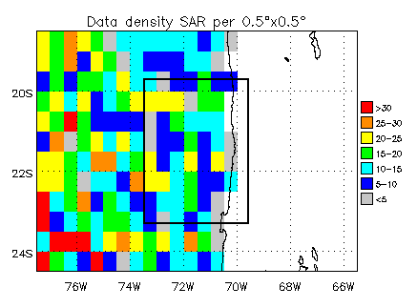

Offshore gridpoint (22˚00’S,71˚15’W) on the Pacific near the west coast of Chile
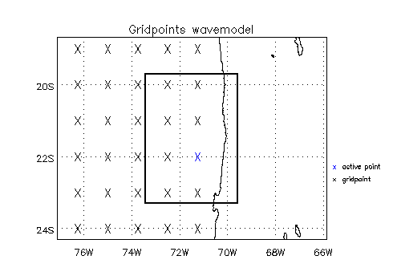

Nearshore location on the west coast of Chile (23˚01’S,70˚24’W) with seaward normal at 305˚ and 100m water depth
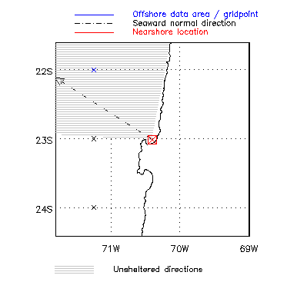

Offshore climate

To illustrate the prevalence of two different swell systems offshore, two representative observed SAR and co-located WAM wave model spectra are shown below.

Energy spectrum #1 (merged spectra are used by waveclimate.com).
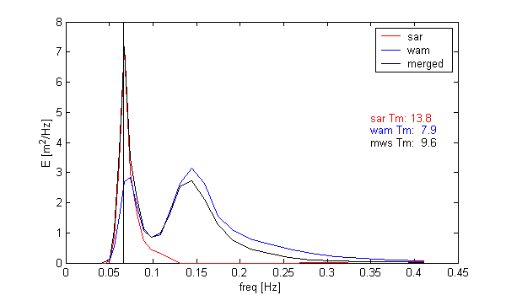

Directional spectrum #1 (merged spectra are used by waveclimate.com)
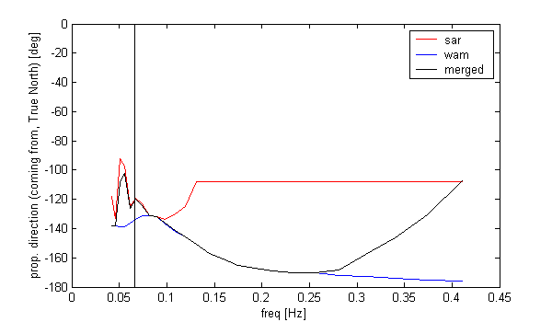

Energy spectrum spectrum #2 (merged spectra are used by waveclimate.com)
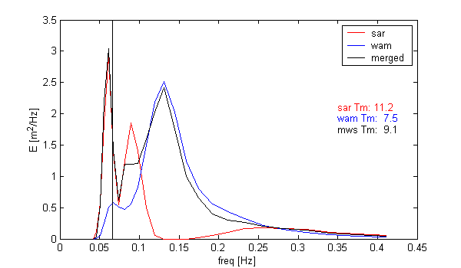

Directional spectrum #2 (merged spectra are used by waveclimate.com)
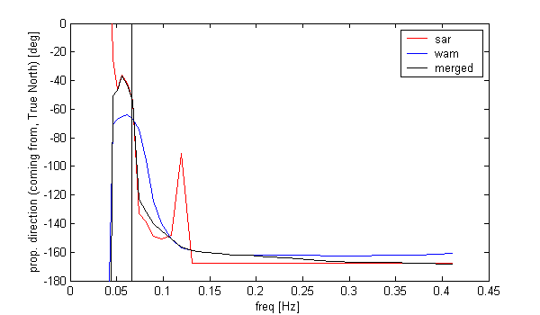

We see long swell waves with wave periods above 15 s coming in from northwest. These are much more prominent in the SAR spectra than in the WAM spectra. The dominant shorter swell coming from southwest is clearly present in the WAM spectra but is generally too short to be detected by SAR. When computing offshore mean period and mean direction, the longer swell from northwest is overruled by the shorter swell from southwest.

This is also illustrated by the offshore scatter tables from waveclimate.com in Appendix 3.

Nearshore climate

As waves from southwest are sheltered, waves from the north-west dominate the nearshore climate even though they are not represented by the offshore integral wave parameters. This is shown by comparing the scatter tables of nearshore wave parameters, also shown in Appendix 3, to the tables for offshore parameters. This is the reason why sheltering, refraction and shoaling are applied to full two-dimensional spectra rather than to integral parameters like significant wave height, mean period and mean direction.

The scatter tables in Appendix 3 also show that nearshore results based on wave model spectra are similar to SAR-based results: for both cases, the swell from the north-west appears in the scatter tables.

Bottom friction test in the Arabian Gulf

Situation

Bottom friction was tested for a site in the Arabian Gulf (Persian Gulf) at (26° 41'N, 50° 9'E). Dissipation due to bottom friction governs the nearshore waveclimate at this site because waves travel over a large area of shallow water before reaching the shore. Depth at the nearshore location is set to 2 m and increases gradually to 50 m along the seaward normal over a distance of approximately 50 km. The test involved:
- A comparison of the nearshore wave climate with- and without taking bottom friction into account
- A comparison of the nearshore climate with bottom friction from our on-line model driven by offshore SAR spectra, and from the SWAN shallow-water wave model.

Offshore wave spectra observed by the SAR sensor were transformed to nearshore, taking bottom friction into account. The SAR-based map of averaged significant wave height and wave direction offshore, is sketched below. It shows waves of up to 1.5 m travelling parallel to the main axis of the basin. The mean sea state is consistent with the mean wind field shown in the next figure.

Prevalent offshore waves (sign. wave height and mean direction) and wind over the Gulf.
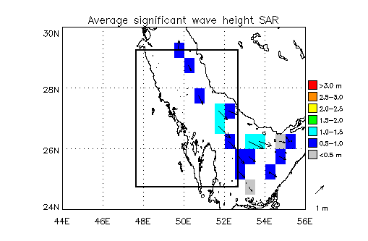

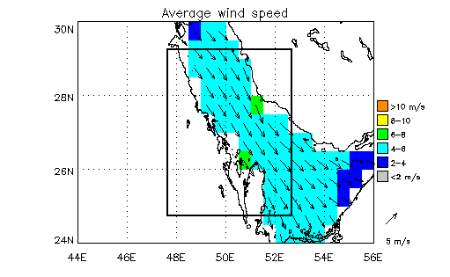

SAR spectra representing the offshore wave conditions were taken from a 500 km x 500 km area displayed in the figures above. This large area was chosen because the density of SAR spectra over the Gulf is low and we want to retain at least about 100 samples for a wave climate estimate (soon, we will have 3-hourly wave hindcast data over a period of 5 years available in the Gulf so the data volume is always sufficient; we will repeat the test with these data). The prevalent offshore wind field shows moderate north-westerly winds ranging from 4-6 m/s.which is consistent with the SAR spectra

The selected nearshore location is at (26° 41'N, 50° 09'E) along the western boundary of the Gulf. The following picture shows the site, the coastline, the coastal normal at 45° (relative to true north, positive clockwise) and the unsheltered wave directions (striped area) A depth of 2 m was chosen for the output location.

Nearshore location at (26° 41'N, 50° 09'E)
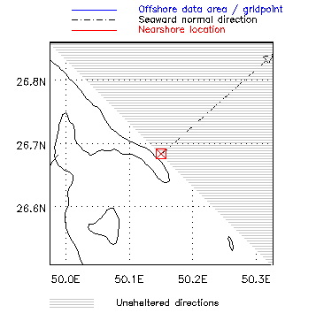

If bottom friction is activated, the user of waveclimate.com is asked to specify a seabed profile along the seaward normal (values of seabed elevation and offshore distance from the output location). This profile can for example be determined from a chart by measuring the distances to a number of depth contours with a ruler. Water-level is assumed to remain unchanged along the seaward normal (normally, only the water level at the output location really matters). Water depth is then computed as water-level minus seabed-level (so make sure they are specified relative to the same datum) . For this site, we entered the following profile

- at 0 m the seabed is at –2 m (this is the nearshore location)
- at 500 m the seabed is at –5 m
- at 1k m the seabed is at –10 m
- at 5 km the seabed is at –20 m
- at 10 km the seabed is at –30 m
- at 50 km the seabed is at –50 m.

estimated from a chart of the local bathymetry. The (constant) water-level was set to zero.

Results of the waveclimate.com model

Appendix 4 lists the scatter tables of wave height versus mean wave period and wave height versus wave direction computed by our on-line wave model, i.e. one pair of tables illustrating

- The offshore waveclimate
- The nearshore waveclimate without bottom friction
- The nearshore waveclimate taking bottom friction into account

The scatter tables of offshore wave height versus wave direction and wave height versus mean wave period show waves of up to 2.4 m mainly coming from the north-northwest but also from the southeast. The second table shows that waves are mostly relatively steep (wind-sea) waves. A few cases of low, much longer waves are also present which are most likely artefacts due to sea surface slicks present during the SAR image acquisition (these are normally filtered out but occasionally some may slip through in the (sub) tropics).

Running the offshore-to-nearshore transformation ignoring bottom friction leads to nearshore waves at 2 m depth of up to 1 m coming from north to north-east as shown in the first scatter table below. Note that the dominant offshore waves coming from north-west are sheltered The fourth table however, reveals long waves with periods of 12-13 s and heights of 0.6-0.8 m arriving at the nearshore site which is not realistic considering the small slope of the foreshore.

After switching on bottom friction and using the seabed profile mentioned above, the unrealistic long waves now disappear. As can be expected (from the formulation of bottom friction; see paragraph 2.4) long waves dissipate (more) strongly (than short waves). Nearshore wave period does not exceed 6 s now. In addition, bottom dissipation diminishes nearshore wave height such that waves above 0.8 m disappear.

Comparison to SWAN wave model results

In this section, we compare wave climate at the nearshore location obtained by waveclimate.com from wave spectra obtained from SAR to results obtained with the shallow-water wave model SWAN. This model was applied by Delft Hydraulics to compute the nearshore climate in preparation of a morphological modelling study. The SWAN model is developed at the Environmental Fluid Mechanics section of the Faculty of Civil Engineering and Geosciences at Delft University of Technology, The Netherlands. It is the first 3rd generation wave model adapted to application in coastal waters and is now widely used by many researchers and engineers around the world. The original wave growth, dissipation and interaction terms resemble those of the ocean wave model WAM but gradually new shallow-water processes and improved formulations are being added. Delft Hydraulics has integrated the SWAN model in several models and applies these in consultancy projects.

Distribution functions of significant wave height and wave period are plotted below, both offshore and nearshore. “SAR” refers to waveclimate.com. In order to make the effect of bottom friction more explicit, we also plotted the results of the offshore-to-nearshore-transformation obtained without bottom friction.

We see that

- Offshore, SAR gives somewhat higher waves than the deep-water conditions applied in SWAN. However nearshore, the significant wave height distribution functions are very similar even in the details.
- Switching off bottom friction (using waveclimate.com with offshore conditions from SAR) reduces the fraction of wave heights of around 0.5 m considerably and increases the fraction of waves between 0.5 m and 1.0 m.

Indeed, bottom friction reduces the heights of certain waves considerably. We would expect that it is the longer waves that are reduced in height. This is indeed the case as we see in the following figure, showing the probability distributions of wave period with different models and input data:

- The fraction of wave periods above 5 s from SAR (offshore) is reduced by the model with bottom friction, and the fraction of wave periods below 5 s is increased.
- Without bottom friction, the nearshore distribution function of periods is practically the same as it is offshore.
- Very large differences are observed between wave periods from SWAN and from waveclimate.com (“SAR”). Offshore, SAR wave periods are already longer (even more so as “SAR” is the “mean period” Tm_{-1,0} whereas SWAN results are in terms of the peak period, which is longer for regular wind-sea spectra). Nearshore, the difference is much larger; SWAN periods nearshore are little more than half of the offshore periods. The waveclimate.com nearshore periods are somewhat lower than the offshore periods due to bottom friction, but not much.

Because the bottom friction formulation in waveclimate.com is practically identical to that in SWAN, this cannot explain the large difference in nearshore periods. The most likely explanation is the behaviour of whitecapping in SWAN. Whitecapping dissipation balances wave growth by wind and interactions on deep water, and these processes are also active on shallow water. The standard whitecapping source term in SWAN (taken from the WAM model) has the peculiarity that wave growth is strongly accelerated if some longer waves of low steepness are already present, and that a growing wind-sea can rapidly dissipate existing longer waves. This behaviour is unphysical; long waves do not dissipate due to short waves (rather the opposite is true). This problem of SWAN and some workarounds were investigated by the Office of Naval Research and published in

Rogers, E.W., P.A. Hwang, D.A. Wang, 2002, Investigation of wave growth and decay in the SWAN model: three regional-scale applications. Journal of Physical Oceanography, Vol.. 33, pp. 366-389.

The example demonstrates that a complex model does not always produce better results, because some physical processes have not been developed far enough in current 3rd generation models to make them suitable for routine application. The shallow-water wave transformation implemented in waveclimate.com is relatively simple, but it is fairly robust.

From the probability distributions of mean wave direction plotted above, we see that

- Offshore directional distributions of SWAN and SAR match (almost) perfectly
- Nearshore directional distributions match fairly well. Both SAR and SWAN curves show two wave systems: one coming from the southeast (offshore directions around 120°) and the other from the northwest (offshore directions around 330°). Both wave systems turn towards the coastal normal (at 45°) while approaching the shore.
- The waveclimate.com model (“SAR”) refracts the waves stronger than SWAN. The most likely explanation is that the SWAN nearshore waves are much shorter so refraction is weaker.

The overall picture is:

- Bottom friction can be useful in situations with a long relatively shallow foreshore. In the present test, the effect is limited because wave periods offshore are not very long. However, on shallow foreshores exposed to long waves from the ocean, the impact of bottom friction can be much larger.
- Simplicity of the shallow-water wave transformation in waveclimate.com makes it a fairly robust tool for rapid assessment of the nearshore climate. More complex models like SWAN are not recommended for this purpose unless applied in the context of more elaborate studies by wave modelling experts.

Conclusions

- The full spectral nearshore wave transformation applied in waveclimate.com detects wave systems which are dominant nearshore, but which are not dominant offshore. This was demonstrated for long relatively low swell waves propagating to a partially sheltered coastal site on the west coast of Chile.
- In-situ measurements of wave height and wave directions in water of 8 m depth compare well to waveclimate.com results at a location on the east coast of the USA.
- Buoy observations of wave height in a nearshore area sheltered by islands compare well to waveclimate.com results. This was shown for a location on the west coast of the USA.
- The offshore data source, i.e. the offshore data area used to select satellite observations or the offshore wave model point, should be representative for the unsheltered deep-water conditions affecting the nearshore wave climate at the nearshore location.
- The offshore to nearshore translation can be based on either observed SAR spectra (taken from a specified offshore area) or computed wave model spectra (from the selected model output point). In our test case, the nearshore results based on SAR spectra are slightly closer to the buoy observations than the nearshore results based on wave model spectra.
- Dissipation of wave energy due to bottom friction can reduce the height of long waves considerably while travelling over a long stretch of shallow water (relative to the wavelength). If the foreshore is not steep, we recommend to switch on the computation of bottom friction. The depth information required can easily be obtained from e.g. a nautical chart of the area of interest.

Appendices

Appendix 1 Scatter tables Duck Beach

Nearshore waveclimate

Scatter table based on SAR spectra (nearshore)
Percentage of occurrence of sign. wave height (m) in rows versus wave direction in columns
 | lower | 337.5 | 22.5 | 67.5 | 112.5 | 157.5 | 202.5 | 247.5 | 292.5
lower | upper | 22.5 | 67.5 | 112.5 | 157.5 | 202.5 | 247.5 | 292.5 | 337.5 | total
0.0 | 0.5 | 0.80 | 4.59 | 25.97 | 0.11 | 0 | 0 | 0 | 0 | 31.47
0.5 | 1.0 | 0.70 | 11.89 | 23.78 | 0.70 | 0 | 0 | 0 | 0 | 37.07
1.0 | 1.5 | 0 | 10.49 | 7.69 | 0 | 0 | 0 | 0 | 0 | 18.18
1.5 | 2.0 | 0 | 0 | 5.59 | 0 | 0 | 0 | 0 | 0 | 5.59
2.0 | 2.5 | 0 | 2.80 | 0.70 | 0 | 0 | 0 | 0 | 0 | 3.50
2.5 | 3.0 | 0 | 0.70 | 0.70 | 0 | 0 | 0 | 0 | 0 | 1.40
3.0 | 3.5 | 0 | 0 | 0 | 0 | 0 | 0 | 0 | 0 | 0.00
3.5 | 4.0 | 0 | 0 | 1.40 | 0 | 0 | 0 | 0 | 0 | 1.40
4.0 | 4.5 | 0 | 0.70 | 0.70 | 0 | 0 | 0 | 0 | 0 | 1.40
4.5 |  | 0 | 0 | 0 | 0 | 0 | 0 | 0 | 0 | 0.00
total |  | 1.50 | 31.17 | 66.53 | 0.81 | 0.00 | 0.00 | 0.00 | 0.00
Copyright ARGOSS, September 2003

Nearshore location is at 36°11'14''N, 75°44'22''W
Depth at nearshore location is 8 m
Seaward normal direction is 70 degrees
Centre of area is at 36° 10'N, 75° 00'W
Size of area is 200x200 km
Season is all year
Variables are sign. wave height (m) and wave direction (deg)
Data source is sar
Results are based on 143 samples from 143 passes
Distance between centre of area and nearshore location is 66 km
Direction convention is "coming from"

Scatter table based on wave model spectra (nearshore)
Percentage of occurrence of sign. wave height (m) in rows versus wave direction in columns
 | lower | 337.5 | 22.5 | 67.5 | 112.5 | 157.5 | 202.5 | 247.5 | 292.5
lower | upper | 22.5 | 67.5 | 112.5 | 157.5 | 202.5 | 247.5 | 292.5 | 337.5 | total
0.0 | 0.5 | 1.26 | 6.45 | 25.69 | 1.65 | 0 | 0 | 0 | 0 | 35.05
0.5 | 1.0 | 1.24 | 10.07 | 14.53 | 1.46 | 0 | 0 | 0 | 0 | 27.30
1.0 | 1.5 | 0.34 | 9.69 | 7.06 | 0.27 | 0 | 0 | 0 | 0 | 17.36
1.5 | 2.0 | 0.01 | 6.63 | 2.75 | 0.07 | 0 | 0 | 0 | 0 | 9.46
2.0 | 2.5 | 0 | 3.62 | 1.26 | 0 | 0 | 0 | 0 | 0 | 4.88
2.5 | 3.0 | 0 | 1.68 | 0.87 | 0 | 0 | 0 | 0 | 0 | 2.55
3.0 | 3.5 | 0 | 1.22 | 0.66 | 0 | 0 | 0 | 0 | 0 | 1.88
3.5 | 4.0 | 0 | 0.60 | 0.25 | 0 | 0 | 0 | 0 | 0 | 0.85
4.0 | 4.5 | 0 | 0.60 | 0.03 | 0 | 0 | 0 | 0 | 0 | 0.63
4.5 | 5.0 | 0 | 0.04 | 0 | 0 | 0 | 0 | 0 | 0 | 0.04
5.0 |  | 0 | 0 | 0 | 0 | 0 | 0 | 0 | 0 | 0.00
total |  | 2.85 | 40.60 | 53.10 | 3.45 | 0.00 | 0.00 | 0.00 | 0.00
Copyright ARGOSS, January 2004
Your choices :
Nearshore location is at 36°11'14''N, 75°44'22''W
Depth at nearshore location is 8 m
Seaward normal direction is 70 degrees
Bottom friction has been switched off
Model ouput point is 36° 00'N, 75° 00'W
Season is all year
Variables are sign. wave height (m) and wave direction (deg)
Data source is wavemodel
Results are based on 14429 samples from 1 model point
Distance between model point and nearshore location is 70 km
Direction convention is "coming from"

Appendix 2 Scatter tables California

Offshore waveclimate

Scatter table of wave height vs. wave direction (SAR, offshore)
Percentage of occurrence of sign. wave height (m) in rows versus wave direction in columns
 | lower | 337.5 | 22.5 | 67.5 | 112.5 | 157.5 | 202.5 | 247.5 | 292.5
lower | upper | 22.5 | 67.5 | 112.5 | 157.5 | 202.5 | 247.5 | 292.5 | 337.5 | total
0.0 | 0.5 | 0 | 0 | 0 | 0 | 0 | 0 | 0 | 0 | 0.00
0.5 | 1.0 | 0 | 0 | 0 | 0 | 0 | 0.53 | 0.35 | 0 | 0.88
1.0 | 1.5 | 0 | 0 | 0 | 0 | 0.35 | 7.24 | 8.13 | 1.41 | 17.13
1.5 | 2.0 | 0.35 | 0 | 0 | 0 | 0.18 | 3.89 | 16.08 | 9.54 | 30.04
2.0 | 2.5 | 0.53 | 0 | 0 | 0 | 0 | 0.18 | 8.30 | 11.66 | 20.67
2.5 | 3.0 | 0.35 | 0 | 0 | 0 | 0 | 0.18 | 2.83 | 9.72 | 13.08
3.0 | 3.5 | 0.18 | 0 | 0 | 0 | 0 | 0 | 2.12 | 6.36 | 8.66
3.5 | 4.0 | 0.18 | 0 | 0 | 0 | 0 | 0.18 | 1.06 | 2.47 | 3.89
4.0 | 4.5 | 0 | 0 | 0 | 0 | 0 | 0 | 0.53 | 2.65 | 3.18
4.5 | 5.0 | 0 | 0 | 0 | 0 | 0 | 0 | 0.18 | 1.06 | 1.24
5.0 | 5.5 | 0 | 0 | 0 | 0 | 0 | 0 | 0 | 0.53 | 0.53
5.5 | 6.0 | 0 | 0 | 0 | 0 | 0 | 0 | 0 | 0.53 | 0.53
6.0 | 6.5 | 0 | 0 | 0 | 0 | 0 | 0 | 0 | 0.18 | 0.18
6.5 |  | 0 | 0 | 0 | 0 | 0 | 0 | 0 | 0 | 0.00
total |  | 1.59 | 0.00 | 0.00 | 0.00 | 0.53 | 12.20 | 39.58 | 46.11
Copyright ARGOSS, October 2003
Your choices :
Centre of area is at 33° 30'N,120° 30'W
Size of area is 500x500 km
Season is all year
Variables are sign. wave height (m) and wave direction (deg)
Data source is sar
Results are based on 566 samples from 374 passes
Direction convention is "coming from"

Scatter table of height of wind-sea vs. direction of wind-sea (SAR, offshore)
Percentage of occurrence of height of wind sea (m) in rows versus direction of wind sea in columns
 | lower | 337.5 | 22.5 | 67.5 | 112.5 | 157.5 | 202.5 | 247.5 | 292.5
lower | upper | 22.5 | 67.5 | 112.5 | 157.5 | 202.5 | 247.5 | 292.5 | 337.5 | total
0.0 | 0.5 | 4.55 | 0.71 | 0.18 | 0.18 | 0.70 | 3.51 | 8.26 | 22.92 | 41.01
0.5 | 1.0 | 2.12 | 0 | 0 | 0 | 0.35 | 1.24 | 2.30 | 11.13 | 17.14
1.0 | 1.5 | 1.06 | 0 | 0 | 0 | 0.71 | 0.18 | 0.71 | 11.48 | 14.14
1.5 | 2.0 | 1.24 | 0 | 0 | 0 | 0 | 0.18 | 0 | 9.19 | 10.61
2.0 | 2.5 | 1.94 | 0 | 0 | 0 | 0 | 0 | 0.35 | 6.89 | 9.18
2.5 | 3.0 | 1.06 | 0 | 0 | 0 | 0 | 0 | 0.35 | 3.18 | 4.59
3.0 | 3.5 | 0 | 0 | 0 | 0 | 0 | 0.18 | 0 | 1.94 | 2.12
3.5 | 4.0 | 0.18 | 0 | 0 | 0 | 0 | 0 | 0.18 | 0.35 | 0.71
4.0 | 4.5 | 0 | 0 | 0 | 0 | 0 | 0 | 0 | 0.35 | 0.35
4.5 | 5.0 | 0 | 0 | 0 | 0 | 0 | 0 | 0 | 0.18 | 0.18
5.0 |  | 0 | 0 | 0 | 0 | 0 | 0 | 0 | 0 | 0.00
total |  | 12.15 | 0.71 | 0.18 | 0.18 | 1.76 | 5.29 | 12.15 | 67.61
Copyright ARGOSS, October 2003
Your choices :
Centre of area is at 33° 30'N,120° 30'W
Size of area is 500x500 km
Season is all year
Variables are height of wind sea (m) and direction of wind sea (deg)
Datasource is sar
Results are based on 566 samples from 374 passes
Direction convention is "coming from"

Scatter table of height of swell vs. direction of swell (SAR, offshore)
Percentage of occurrence of height of swell (m) in rows versus direction of swell in columns
 | lower | 337.5 | 22.5 | 67.5 | 112.5 | 157.5 | 202.5 | 247.5 | 292.5
lower | upper | 22.5 | 67.5 | 112.5 | 157.5 | 202.5 | 247.5 | 292.5 | 337.5 | total
0.0 | 0.5 | 0 | 0 | 0 | 0 | 1.24 | 0.53 | 0.18 | 0 | 1.95
0.5 | 1.0 | 0 | 0 | 0 | 0 | 2.12 | 3.71 | 1.77 | 0 | 7.60
1.0 | 1.5 | 0 | 0 | 0 | 0.18 | 1.59 | 11.31 | 12.37 | 3.18 | 28.63
1.5 | 2.0 | 0 | 0 | 0 | 0 | 0.35 | 5.48 | 13.43 | 9.19 | 28.45
2.0 | 2.5 | 0 | 0 | 0 | 0 | 0 | 0.35 | 7.60 | 7.95 | 15.90
2.5 | 3.0 | 0 | 0 | 0 | 0 | 0 | 0.18 | 1.77 | 5.83 | 7.78
3.0 | 3.5 | 0 | 0 | 0 | 0 | 0 | 0 | 2.30 | 3.00 | 5.30
3.5 | 4.0 | 0 | 0 | 0 | 0 | 0 | 0 | 0.35 | 1.59 | 1.94
4.0 | 4.5 | 0 | 0 | 0 | 0 | 0 | 0 | 0.35 | 1.24 | 1.59
4.5 | 5.0 | 0 | 0 | 0 | 0 | 0 | 0 | 0.18 | 0.35 | 0.53
5.0 | 5.5 | 0 | 0 | 0 | 0 | 0 | 0 | 0 | 0.35 | 0.35
5.5 |  | 0 | 0 | 0 | 0 | 0 | 0 | 0 | 0 | 0.00
total |  | 0.00 | 0.00 | 0.00 | 0.18 | 5.30 | 21.56 | 40.30 | 32.68
Copyright ARGOSS, October 2003
Your choices :
Centre of area is at 33° 30'N,120° 30'W
Size of area is 500x500 km
Season is all year
Variables are height of swell (m) and direction of swell (deg)
Datasource is sar
Results are based on 566 samples from 374 passes
Direction convention is "coming from"

Scatter table of wave height vs. wave direction (wave model, offshore)
Percentage of occurrence of sign. wave height (m) in rows versus wave direction in columns
 | lower | 337.5 | 22.5 | 67.5 | 112.5 | 157.5 | 202.5 | 247.5 | 292.5
lower | upper | 22.5 | 67.5 | 112.5 | 157.5 | 202.5 | 247.5 | 292.5 | 337.5 | total
0.0 | 0.5 | 0 | 0 | 0 | 0 | 0 | 0 | 0 | 0 | 0.00
0.5 | 1.0 | 0 | 0 | 0 | 0 | 0 | 0.06 | 0.34 | 0.03 | 0.43
1.0 | 1.5 | 0 | 0 | 0 | 0 | 0 | 0.38 | 6.11 | 5.90 | 12.39
1.5 | 2.0 | 0 | 0 | 0 | 0 | 0.03 | 0.39 | 6.36 | 18.52 | 25.30
2.0 | 2.5 | 0 | 0 | 0 | 0 | 0.05 | 0.37 | 3.38 | 18.78 | 22.58
2.5 | 3.0 | 0 | 0 | 0 | 0 | 0.08 | 0.13 | 2.80 | 13.11 | 16.12
3.0 | 3.5 | 0 | 0 | 0 | 0 | 0 | 0.07 | 2.34 | 7.34 | 9.75
3.5 | 4.0 | 0 | 0 | 0 | 0 | 0.01 | 0.05 | 1.85 | 3.99 | 5.90
4.0 | 4.5 | 0 | 0 | 0 | 0 | 0.01 | 0.03 | 0.98 | 2.38 | 3.40
4.5 | 5.0 | 0 | 0 | 0 | 0 | 0.02 | 0 | 0.67 | 1.20 | 1.89
5.0 | 5.5 | 0 | 0 | 0 | 0 | 0 | 0 | 0.40 | 0.53 | 0.93
5.5 | 6.0 | 0 | 0 | 0 | 0 | 0.01 | 0.03 | 0.30 | 0.23 | 0.57
6.0 | 6.5 | 0 | 0 | 0 | 0 | 0 | 0.02 | 0.31 | 0.04 | 0.37
6.5 | 7.0 | 0 | 0 | 0 | 0 | 0 | 0 | 0.23 | 0.01 | 0.24
7.0 | 7.5 | 0 | 0 | 0 | 0 | 0 | 0 | 0.12 | 0 | 0.12
7.5 | 8.0 | 0 | 0 | 0 | 0 | 0 | 0 | 0.03 | 0 | 0.03
8.0 |  | 0 | 0 | 0 | 0 | 0 | 0 | 0 | 0 | 0.00
total |  | 0.00 | 0.00 | 0.00 | 0.00 | 0.21 | 1.53 | 26.22 | 72.06
Copyright ARGOSS, January 2004
Your choices :
Model ouput point is 35° 00'N,122° 30'W
Season is all year
Variables are sign. wave height (m) and wave direction (deg)
Data source is wavemodel
Results are based on 14429 samples from 1 model point
Direction convention is "coming from"

Scatter table of height of wind-sea vs. direction of wind-sea (wave model, offshore)
Percentage of occurrence of height of wind sea (m) in rows versus direction of wind sea in columns
 | lower | 337.5 | 22.5 | 67.5 | 112.5 | 157.5 | 202.5 | 247.5 | 292.5
lower | upper | 22.5 | 67.5 | 112.5 | 157.5 | 202.5 | 247.5 | 292.5 | 337.5 | total
0.0 | 0.5 | 4.56 | 0.11 | 0.07 | 0.45 | 1.92 | 2.55 | 2.72 | 32.01 | 44.39
0.5 | 1.0 | 2.49 | 0.03 | 0.03 | 0.15 | 1.03 | 0.99 | 1.03 | 17.80 | 23.55
1.0 | 1.5 | 1.09 | 0 | 0.01 | 0.08 | 0.61 | 0.35 | 0.37 | 14.73 | 17.24
1.5 | 2.0 | 0.18 | 0 | 0 | 0.04 | 0.18 | 0.21 | 0.10 | 7.89 | 8.60
2.0 | 2.5 | 0 | 0 | 0 | 0.01 | 0.06 | 0.08 | 0.14 | 3.62 | 3.91
2.5 | 3.0 | 0 | 0 | 0 | 0 | 0.04 | 0.01 | 0.05 | 1.34 | 1.44
3.0 | 3.5 | 0 | 0 | 0 | 0 | 0.04 | 0 | 0.01 | 0.51 | 0.56
3.5 | 4.0 | 0 | 0 | 0 | 0 | 0.02 | 0 | 0.01 | 0.19 | 0.22
4.0 | 4.5 | 0 | 0 | 0 | 0 | 0.01 | 0.01 | 0.01 | 0.04 | 0.07
4.5 | 5.0 | 0 | 0 | 0 | 0 | 0 | 0 | 0 | 0.03 | 0.03
5.0 |  | 0 | 0 | 0 | 0 | 0 | 0 | 0 | 0 | 0.00
total |  | 8.32 | 0.14 | 0.11 | 0.73 | 3.91 | 4.20 | 4.44 | 78.16
Copyright ARGOSS, January 2004
Your choices :
Model ouput point is 35° 00'N,122° 30'W
Season is all year
Variables are height of wind sea (m) and direction of wind sea (deg)
Data source is wavemodel
Results are based on 14429 samples from 1 model point
Direction convention is "coming from"

Scatter table of height of swell vs. direction of swell (wave model, offshore)
Percentage of occurrence of height of swell (m) in rows versus direction of swell in columns
 | lower | 337.5 | 22.5 | 67.5 | 112.5 | 157.5 | 202.5 | 247.5 | 292.5
lower | upper | 22.5 | 67.5 | 112.5 | 157.5 | 202.5 | 247.5 | 292.5 | 337.5 | total
0.0 | 0.5 | 0 | 0 | 0 | 0 | 0 | 0 | 0 | 0 | 0.00
0.5 | 1.0 | 0 | 0 | 0 | 0 | 0 | 0.21 | 1.32 | 0.17 | 1.70
1.0 | 1.5 | 0 | 0 | 0 | 0 | 0 | 1.01 | 11.17 | 9.06 | 21.24
1.5 | 2.0 | 0 | 0 | 0 | 0 | 0 | 0.48 | 8.48 | 19.16 | 28.12
2.0 | 2.5 | 0 | 0 | 0 | 0 | 0.01 | 0.21 | 3.65 | 15.14 | 19.01
2.5 | 3.0 | 0 | 0 | 0 | 0 | 0.01 | 0.06 | 3.17 | 8.79 | 12.03
3.0 | 3.5 | 0 | 0 | 0 | 0 | 0.01 | 0.01 | 2.54 | 5.15 | 7.71
3.5 | 4.0 | 0 | 0 | 0 | 0 | 0.01 | 0.01 | 1.66 | 2.64 | 4.32
4.0 | 4.5 | 0 | 0 | 0 | 0 | 0 | 0.02 | 0.98 | 1.52 | 2.52
4.5 | 5.0 | 0 | 0 | 0 | 0 | 0 | 0 | 0.67 | 0.83 | 1.50
5.0 | 5.5 | 0 | 0 | 0 | 0 | 0 | 0.01 | 0.43 | 0.32 | 0.76
5.5 | 6.0 | 0 | 0 | 0 | 0 | 0 | 0.01 | 0.31 | 0.14 | 0.46
6.0 | 6.5 | 0 | 0 | 0 | 0 | 0 | 0 | 0.34 | 0.03 | 0.37
6.5 | 7.0 | 0 | 0 | 0 | 0 | 0 | 0 | 0.15 | 0.01 | 0.16
7.0 | 7.5 | 0 | 0 | 0 | 0 | 0 | 0 | 0.08 | 0 | 0.08
7.5 |  | 0 | 0 | 0 | 0 | 0 | 0 | 0 | 0 | 0.00
total |  | 0.00 | 0.00 | 0.00 | 0.00 | 0.04 | 2.03 | 34.95 | 62.96
Copyright ARGOSS, January 2004
Your choices :
Model ouput point is 35° 00'N,122° 30'W
Season is all year
Variables are height of swell (m) and direction of swell (deg)
Data source is wavemodel
Results are based on 14429 samples from 1 model point
Direction convention is "coming from"

Nearshore waveclimate

Scatter table of wave height vs. wave direction (SAR, nearshore)
Percentage of occurrence of sign. wave height (m) in rows versus wave direction in columns
 | lower | 337.5 | 22.5 | 67.5 | 112.5 | 157.5 | 202.5 | 247.5 | 292.5
lower | upper | 22.5 | 67.5 | 112.5 | 157.5 | 202.5 | 247.5 | 292.5 | 337.5 | total
0.0 | 0.5 | 0 | 0 | 0 | 0 | 0 | 0 | 4.42 | 0 | 4.42
0.5 | 1.0 | 0 | 0 | 0 | 0 | 0 | 0 | 41.34 | 0 | 41.34
1.0 | 1.5 | 0 | 0 | 0 | 0 | 0 | 0 | 31.63 | 0 | 31.63
1.5 | 2.0 | 0 | 0 | 0 | 0 | 0 | 0 | 13.25 | 0 | 13.25
2.0 | 2.5 | 0 | 0 | 0 | 0 | 0 | 0 | 5.30 | 0 | 5.30
2.5 | 3.0 | 0 | 0 | 0 | 0 | 0 | 0 | 3.36 | 0 | 3.36
3.0 | 3.5 | 0 | 0 | 0 | 0 | 0 | 0 | 0.71 | 0 | 0.71
3.5 |  | 0 | 0 | 0 | 0 | 0 | 0 | 0 | 0 | 0.00
total |  | 0.00 | 0.00 | 0.00 | 0.00 | 0.00 | 0.00 | 100.01 | 0.00
Copyright ARGOSS, October 2003

Your choices :
Nearshore location is at 34°14'10''N,119°51'00''W
Depth at nearshore location is 417 m
Seaward normal direction is 205 degrees
Centre of area is at 33° 30'N,120° 30'W
Size of area is 500x500 km
Season is all year
Variables are sign. wave height (m) and wave direction (deg)
Sensor is sar
Based on 566 samples
from 374 passes
Direction convention is "coming from"

Scatter table of wave height vs. wave direction (wave model, nearshore)
Percentage of occurrence of sign. wave height (m) in rows versus wave direction in columns
 | lower | 337.5 | 22.5 | 67.5 | 112.5 | 157.5 | 202.5 | 247.5 | 292.5
lower | upper | 22.5 | 67.5 | 112.5 | 157.5 | 202.5 | 247.5 | 292.5 | 337.5 | total
0.0 | 0.5 | 0 | 0 | 0 | 0 | 0 | 0 | 7.33 | 0 | 7.33
0.5 | 1.0 | 0 | 0 | 0 | 0 | 0 | 0 | 39.14 | 0 | 39.14
1.0 | 1.5 | 0 | 0 | 0 | 0 | 0 | 0 | 24.71 | 0 | 24.71
1.5 | 2.0 | 0 | 0 | 0 | 0 | 0 | 0 | 13.50 | 0 | 13.50
2.0 | 2.5 | 0 | 0 | 0 | 0 | 0 | 0 | 7.25 | 0 | 7.25
2.5 | 3.0 | 0 | 0 | 0 | 0 | 0 | 0 | 3.90 | 0 | 3.90
3.0 | 3.5 | 0 | 0 | 0 | 0 | 0 | 0 | 1.91 | 0 | 1.91
3.5 | 4.0 | 0 | 0 | 0 | 0 | 0 | 0 | 0.89 | 0 | 0.89
4.0 | 4.5 | 0 | 0 | 0 | 0 | 0 | 0 | 0.56 | 0 | 0.56
4.5 | 5.0 | 0 | 0 | 0 | 0 | 0 | 0 | 0.40 | 0 | 0.40
5.0 | 5.5 | 0 | 0 | 0 | 0 | 0 | 0 | 0.24 | 0 | 0.24
5.5 | 6.0 | 0 | 0 | 0 | 0 | 0 | 0 | 0.15 | 0 | 0.15
6.0 | 6.5 | 0 | 0 | 0 | 0 | 0 | 0 | 0.02 | 0 | 0.02
6.5 |  | 0 | 0 | 0 | 0 | 0 | 0 | 0 | 0 | 0.00
total |  | 0.00 | 0.00 | 0.00 | 0.00 | 0.00 | 0.00 | 100.00 | 0.00
Copyright ARGOSS, January 2004
Your choices :
Nearshore location is at 34°14'10''N,119°51'00''W
Depth at nearshore location is 417 m
Seaward normal direction is 205 degrees
Bottom friction has been switched off
Model ouput point is 35° 00'N,122° 30'W
Season is all year
Variables are sign. wave height (m) and wave direction (deg)
Data source is wavemodel
Results are based on 14429 samples from 1 model point
Distance between model point and nearshore location is 257 km
Direction convention is "coming from"

Appendix 3 Scatter tables Chile

Offshore waveclimate

Scatter table wave height vs. wave direction (SAR, offshore)
Percentage of occurrence of sign. wave height (m) in rows versus wave direction in columns
 | lower | 337.5 | 22.5 | 67.5 | 112.5 | 157.5 | 202.5 | 247.5 | 292.5
lower | upper | 22.5 | 67.5 | 112.5 | 157.5 | 202.5 | 247.5 | 292.5 | 337.5 | total
0.0 | 0.5 | 0 | 0 | 0 | 0 | 0 | 0 | 0 | 0 | 0.0
0.5 | 1.0 | 0 | 0 | 0 | 0 | 0 | 0.6 | 0 | 0 | 0.6
1.0 | 1.5 | 0 | 0 | 0 | 0 | 0.6 | 16.8 | 0.4 | 0 | 17.8
1.5 | 2.0 | 0 | 0 | 0 | 0 | 2.6 | 29.3 | 0.2 | 0 | 32.1
2.0 | 2.5 | 0 | 0 | 0 | 0 | 6.6 | 19.2 | 1.0 | 0 | 26.8
2.5 | 3.0 | 0 | 0 | 0 | 0 | 3.2 | 11.4 | 0.2 | 0 | 14.8
3.0 | 3.5 | 0 | 0 | 0 | 0 | 1.4 | 4.0 | 0.2 | 0 | 5.6
3.5 | 4.0 | 0 | 0 | 0 | 0 | 0.4 | 1.0 | 0 | 0 | 1.4
4.0 | 4.5 | 0 | 0 | 0 | 0 | 0 | 0.6 | 0 | 0 | 0.6
4.5 | 5.0 | 0 | 0 | 0 | 0 | 0 | 0.2 | 0 | 0 | 0.2
5.0 |  | 0 | 0 | 0 | 0 | 0 | 0 | 0 | 0 | 0.0
total |  | 0.0 | 0.0 | 0.0 | 0.0 | 14.8 | 83.1 | 2.0 | 0.0
Copyright ARGOSS, June 2003
Your choices :
Centre of area is at 21° 30'S, 71° 30'W
Size of area is 400x400 km
Season is all year
Variables are sign. wave height (m) and wave direction (deg)
Datasource is sar
Results are based on 499 samples from 302 passes
Direction convention is "coming from"
Scatter table wave height vs. wave period (SAR, offshore)
Percentage of occurrence of sign. wave height (m) in rows versus mean wave period (s) in columns
 | lower | 00 | 06 | 07 | 08 | 09 | 10 | 11 | 12 | 13 | 14 | 15 | 16
lower | upper | 06 | 07 | 08 | 09 | 10 | 11 | 12 | 13 | 14 | 15 | 16 |  | total
0.0 | 0.5 | 0 | 0 | 0 | 0 | 0 | 0 | 0 | 0 | 0 | 0 | 0 | 0 | 0.0
0.5 | 1.0 | 0 | 0 | 0 | 0.2 | 0.4 | 0 | 0 | 0 | 0 | 0 | 0 | 0 | 0.6
1.0 | 1.5 | 0 | 0 | 1.6 | 3.2 | 6.0 | 5.0 | 1.8 | 0.2 | 0 | 0 | 0 | 0 | 17.8
1.5 | 2.0 | 0 | 0.2 | 1.4 | 4.4 | 9.4 | 11.0 | 3.6 | 1.6 | 0 | 0.4 | 0 | 0 | 32.0
2.0 | 2.5 | 0 | 0.2 | 1.0 | 6.6 | 4.4 | 5.6 | 5.0 | 3.4 | 0.2 | 0.2 | 0.2 | 0 | 26.8
2.5 | 3.0 | 0 | 0 | 0.2 | 1.8 | 1.0 | 2.2 | 2.8 | 4.4 | 1.8 | 0.4 | 0.2 | 0 | 14.8
3.0 | 3.5 | 0 | 0 | 0.4 | 0.2 | 1.0 | 1.4 | 0.4 | 0.8 | 1.0 | 0.4 | 0 | 0 | 5.6
3.5 | 4.0 | 0 | 0 | 0 | 0 | 0.2 | 0.4 | 0.4 | 0.2 | 0.2 | 0 | 0 | 0 | 1.4
4.0 | 4.5 | 0 | 0 | 0 | 0 | 0 | 0 | 0.2 | 0.4 | 0 | 0 | 0 | 0 | 0.6
4.5 | 5.0 | 0 | 0 | 0 | 0 | 0 | 0.2 | 0 | 0 | 0 | 0 | 0 | 0 | 0.2
5.0 |  | 0 | 0 | 0 | 0 | 0 | 0 | 0 | 0 | 0 | 0 | 0 | 0 | 0.0
total |  | 0.0 | 0.4 | 4.6 | 16.4 | 22.4 | 25.8 | 14.2 | 11.0 | 3.2 | 1.4 | 0.4 | 0.0
Copyright ARGOSS, June 2003
Your choices :
Centre of area is at 21° 30'S, 71° 30'W
Size of area is 400x400 km
Season is all year
Variables are sign. wave height (m) and mean wave period (s)
Datasource is sar
Results are based on 499 samples from 302 passes
Scatter table swell wave height vs. direction of swell (SAR, offshore)
Percentage of occurrence of height of swell (m) in rows versus direction of swell in columns
 | lower | 337.5 | 22.5 | 67.5 | 112.5 | 157.5 | 202.5 | 247.5 | 292.5
lower | upper | 22.5 | 67.5 | 112.5 | 157.5 | 202.5 | 247.5 | 292.5 | 337.5 | total
0.0 | 0.5 | 0 | 0 | 0 | 0 | 0 | 0 | 0 | 0 | 0.0
0.5 | 1.0 | 0 | 0 | 0 | 0 | 0 | 1.0 | 0 | 0 | 1.0
1.0 | 1.5 | 0 | 0 | 0 | 0 | 0.4 | 19.0 | 0.4 | 0 | 19.8
1.5 | 2.0 | 0 | 0 | 0 | 0 | 2.2 | 33.5 | 0.2 | 0 | 35.9
2.0 | 2.5 | 0 | 0 | 0 | 0 | 4.0 | 19.8 | 1.0 | 0 | 24.8
2.5 | 3.0 | 0 | 0 | 0 | 0 | 1.2 | 11.6 | 0.2 | 0 | 13.0
3.0 | 3.5 | 0 | 0 | 0 | 0 | 0.2 | 3.6 | 0.2 | 0 | 4.0
3.5 | 4.0 | 0 | 0 | 0 | 0 | 0 | 1.0 | 0 | 0 | 1.0
4.0 | 4.5 | 0 | 0 | 0 | 0 | 0 | 0.4 | 0 | 0 | 0.4
4.5 |  | 0 | 0 | 0 | 0 | 0 | 0 | 0 | 0 | 0.0
total |  | 0.0 | 0.0 | 0.0 | 0.0 | 8.0 | 89.9 | 2.0 | 0.0
Copyright ARGOSS, June 2003
Your choices :
Centre of area is at 21° 30'S, 71° 30'W
Size of area is 400x400 km
Season is all year
Variables are height of swell (m) and direction of swell (deg)
Datasource is sar
Results are based on 499 samples from 302 passes
Direction convention is "coming from"

Scatter table swell wave height vs. period of swell (SAR, offshore)
Percentage of occurrence of height of swell (m) in rows versus mean period of swell (s) in columns
 | lower | 00 | 07 | 08 | 09 | 10 | 11 | 12 | 13 | 14 | 15 | 16
lower | upper | 07 | 08 | 09 | 10 | 11 | 12 | 13 | 14 | 15 | 16 |  | total
0.0 | 0.5 | 0 | 0 | 0 | 0 | 0 | 0 | 0 | 0 | 0 | 0 | 0 | 0.0
0.5 | 1.0 | 0 | 0 | 0.2 | 0.8 | 0 | 0 | 0 | 0 | 0 | 0 | 0 | 1.0
1.0 | 1.5 | 0 | 0.4 | 3.6 | 7.4 | 5.6 | 2.2 | 0.6 | 0 | 0 | 0 | 0 | 19.8
1.5 | 2.0 | 0 | 0.4 | 3.0 | 10.8 | 12.2 | 6.4 | 2.4 | 0 | 0.6 | 0 | 0 | 35.8
2.0 | 2.5 | 0 | 0 | 1.6 | 6.2 | 6.2 | 5.4 | 4.6 | 0.4 | 0.2 | 0.2 | 0 | 24.8
2.5 | 3.0 | 0 | 0 | 0 | 0.4 | 1.6 | 2.8 | 5.4 | 2.2 | 0.4 | 0.2 | 0 | 13.0
3.0 | 3.5 | 0 | 0 | 0 | 0 | 0.4 | 0.8 | 1.2 | 1.2 | 0.4 | 0 | 0 | 4.0
3.5 | 4.0 | 0 | 0 | 0 | 0 | 0 | 0 | 0.2 | 0.6 | 0.2 | 0 | 0 | 1.0
4.0 | 4.5 | 0 | 0 | 0 | 0 | 0 | 0.4 | 0 | 0 | 0 | 0 | 0 | 0.4
4.5 |  | 0 | 0 | 0 | 0 | 0 | 0 | 0 | 0 | 0 | 0 | 0 | 0.0
total |  | 0.0 | 0.8 | 8.4 | 25.6 | 26.0 | 18.0 | 14.4 | 4.4 | 1.8 | 0.4 | 0.0
Copyright ARGOSS, June 2003
Your choices :
Centre of area is at 21° 30'S, 71° 30'W
Size of area is 400x400 km
Season is all year
Variables are height of swell (m) and mean period of swell (s)
Datasource is sar
Results are based on 499 samples from 302 passes

Nearshore waveclimate based on SAR spectra

Scatter table wave height vs. wave direction (SAR, nearshore)
Percentage of occurrence of sign. wave height (m) in rows versus wave direction in columns
 | lower | 337.5 | 22.5 | 67.5 | 112.5 | 157.5 | 202.5 | 247.5 | 292.5
lower | upper | 22.5 | 67.5 | 112.5 | 157.5 | 202.5 | 247.5 | 292.5 | 337.5 | total
0.0 | 0.5 | 0 | 0 | 0 | 0 | 0 | 0 | 76.55 | 6.21 | 82.76
0.5 | 1.0 | 0 | 0 | 0 | 0 | 0 | 0 | 9.42 | 5.21 | 14.63
1.0 | 1.5 | 0 | 0 | 0 | 0 | 0 | 0 | 0.80 | 1.40 | 2.20
1.5 | 2.0 | 0 | 0 | 0 | 0 | 0 | 0 | 0.20 | 0 | 0.20
2.0 | 2.5 | 0 | 0 | 0 | 0 | 0 | 0 | 0 | 0.20 | 0.20
2.5 |  | 0 | 0 | 0 | 0 | 0 | 0 | 0 | 0 | 0.00
total |  | 0.00 | 0.00 | 0.00 | 0.00 | 0.00 | 0.00 | 86.97 | 13.02
Copyright ARGOSS, September 2003
Your choices :
Nearshore location is at 23°01'00''S, 70°24'00''W
Depth at nearshore location is 100 m
Seaward normal direction is 305 degrees
Centre of area is at 21° 30'S, 71° 30'W
Size of area is 400x400 km
Season is all year
Variables are sign. wave height (m) and wave direction (deg)
Data source is sar
Results are based on 499 samples from 302 passes
Distance between centre of area and nearshore location is 203 km
Direction convention is "coming from"

Scatter table wave height vs. wave period (SAR, nearshore)
Percentage of occurrence of sign. wave height (m) in rows versus mean wave period (s) in columns
 | lower | 00 | 03 | 04 | 05 | 06 | 07 | 08 | 09 | 10 | 11 | 12 | 13 | 14 | 15 | 16 | 17 | 18 | 19 | 20
lower | upper | 03 | 04 | 05 | 06 | 07 | 08 | 09 | 10 | 11 | 12 | 13 | 14 | 15 | 16 | 17 | 18 | 19 | 20 |  | total
0.0 | 0.5 | 0 | 0.20 | 0 | 0 | 0 | 1.00 | 1.40 | 3.01 | 6.41 | 9.02 | 15.43 | 15.63 | 12.02 | 8.22 | 6.21 | 1.80 | 1.20 | 1.20 | 0 | 82.75
0.5 | 1.0 | 0 | 0 | 0 | 0 | 0 | 0 | 0.20 | 0 | 0 | 0 | 0.60 | 1.60 | 2.40 | 3.01 | 3.01 | 3.21 | 0.60 | 0 | 0 | 14.63
1.0 | 1.5 | 0 | 0 | 0 | 0 | 0 | 0 | 0 | 0 | 0 | 0 | 0 | 0 | 0.20 | 1.00 | 0.60 | 0.40 | 0 | 0 | 0 | 2.20
1.5 | 2.0 | 0 | 0 | 0 | 0 | 0 | 0 | 0 | 0 | 0 | 0 | 0 | 0 | 0 | 0.20 | 0 | 0 | 0 | 0 | 0 | 0.20
2.0 | 2.5 | 0 | 0 | 0 | 0 | 0 | 0 | 0 | 0 | 0 | 0 | 0 | 0 | 0 | 0 | 0.20 | 0 | 0 | 0 | 0 | 0.20
2.5 |  | 0 | 0 | 0 | 0 | 0 | 0 | 0 | 0 | 0 | 0 | 0 | 0 | 0 | 0 | 0 | 0 | 0 | 0 | 0 | 0.00
total |  | 0.00 | 0.20 | 0.00 | 0.00 | 0.00 | 1.00 | 1.60 | 3.01 | 6.41 | 9.02 | 16.03 | 17.23 | 14.62 | 12.43 | 10.02 | 5.41 | 1.80 | 1.20 | 0.00
Copyright ARGOSS, September 2003
Your choices :
Nearshore location is at 23°01'00''S, 70°24'00''W
Depth at nearshore location is 100 m
Seaward normal direction is 305 degrees
Centre of area is at 21° 30'S, 71° 30'W
Size of area is 400x400 km
Season is all year
Variables are sign. wave height (m) and mean wave period (s)
Data source is sar
Results are based on 499 samples from 302 passes
Distance between centre of area and nearshore location is 203 km

Scatter table swell wave height vs. direction of swell (SAR, nearshore)
Percentage of occurrence of height of swell (m) in rows versus direction of swell in columns
 | lower | 337.5 | 22.5 | 67.5 | 112.5 | 157.5 | 202.5 | 247.5 | 292.5
lower | upper | 22.5 | 67.5 | 112.5 | 157.5 | 202.5 | 247.5 | 292.5 | 337.5 | total
0.0 | 0.5 | 0 | 0 | 0 | 0 | 0 | 0 | 76.48 | 6.28 | 82.76
0.5 | 1.0 | 0 | 0 | 0 | 0 | 0 | 0 | 9.42 | 5.21 | 14.63
1.0 | 1.5 | 0 | 0 | 0 | 0 | 0 | 0 | 0.80 | 1.40 | 2.20
1.5 | 2.0 | 0 | 0 | 0 | 0 | 0 | 0 | 0.20 | 0 | 0.20
2.0 | 2.5 | 0 | 0 | 0 | 0 | 0 | 0 | 0 | 0.20 | 0.20
2.5 |  | 0 | 0 | 0 | 0 | 0 | 0 | 0 | 0 | 0.00
total |  | 0.00 | 0.00 | 0.00 | 0.00 | 0.00 | 0.00 | 86.90 | 13.09
Copyright ARGOSS, September 2003
Your choices :
Nearshore location is at 23°01'00''S, 70°24'00''W
Depth at nearshore location is 100 m
Seaward normal direction is 305 degrees
Centre of area is at 21° 30'S, 71° 30'W
Size of area is 400x400 km
Season is all year
Variables are height of swell (m) and direction of swell (deg)
Data source is sar
Results are based on 499 samples from 302 passes
Distance between centre of area and nearshore location is 203 km
Direction convention is "coming from"

Scatter table swell wave height vs. period of swell (SAR, nearshore)
Percentage of occurrence of height of swell (m) in rows versus mean period of swell (s) in columns
 | lower | 00 | 08 | 09 | 10 | 11 | 12 | 13 | 14 | 15 | 16 | 17 | 18 | 19 | 20
lower | upper | 08 | 09 | 10 | 11 | 12 | 13 | 14 | 15 | 16 | 17 | 18 | 19 | 20 |  | total
0.0 | 0.5 | 0 | 0.20 | 2.61 | 4.81 | 10.02 | 15.04 | 16.25 | 13.46 | 9.66 | 6.45 | 1.85 | 1.21 | 1.20 | 0 | 82.76
0.5 | 1.0 | 0 | 0.20 | 0 | 0 | 0 | 0.60 | 1.40 | 2.61 | 3.01 | 3.01 | 3.21 | 0.60 | 0 | 0 | 14.64
1.0 | 1.5 | 0 | 0 | 0 | 0 | 0 | 0 | 0 | 0.20 | 1.00 | 0.60 | 0.40 | 0 | 0 | 0 | 2.20
1.5 | 2.0 | 0 | 0 | 0 | 0 | 0 | 0 | 0 | 0 | 0.20 | 0 | 0 | 0 | 0 | 0 | 0.20
2.0 | 2.5 | 0 | 0 | 0 | 0 | 0 | 0 | 0 | 0 | 0 | 0.20 | 0 | 0 | 0 | 0 | 0.20
2.5 |  | 0 | 0 | 0 | 0 | 0 | 0 | 0 | 0 | 0 | 0 | 0 | 0 | 0 | 0 | 0.00
total |  | 0.00 | 0.40 | 2.61 | 4.81 | 10.02 | 15.64 | 17.65 | 16.27 | 13.87 | 10.26 | 5.46 | 1.81 | 1.20 | 0.00
Copyright ARGOSS, September 2003
Your choices :
Nearshore location is at 23°01'00''S, 70°24'00''W
Depth at nearshore location is 100 m
Seaward normal direction is 305 degrees
Centre of area is at 21° 30'S, 71° 30'W
Size of area is 400x400 km
Season is all year
Variables are height of swell (m) and mean period of swell (s)
Data source is sar
Results are based on 499 samples from 302 passes
Distance between centre of area and nearshore location is 203 km

Nearshore waveclimate based on wave model spectra

Scatter table wave height vs. wave direction (wave model, nearshore)
Percentage of occurrence of sign. wave height (m) in rows versus wave direction in columns
 | lower | 337.5 | 22.5 | 67.5 | 112.5 | 157.5 | 202.5 | 247.5 | 292.5
lower | upper | 22.5 | 67.5 | 112.5 | 157.5 | 202.5 | 247.5 | 292.5 | 337.5 | total
0.0 | 0.5 | 0 | 0 | 0 | 0 | 0 | 0 | 77.74 | 12.21 | 89.95
0.5 | 1.0 | 0 | 0 | 0 | 0 | 0 | 0 | 1.10 | 7.50 | 8.60
1.0 | 1.5 | 0 | 0 | 0 | 0 | 0 | 0 | 0.05 | 1.25 | 1.30
1.5 | 2.0 | 0 | 0 | 0 | 0 | 0 | 0 | 0.01 | 0.15 | 0.16
2.0 |  | 0 | 0 | 0 | 0 | 0 | 0 | 0 | 0 | 0.00
total |  | 0.00 | 0.00 | 0.00 | 0.00 | 0.00 | 0.00 | 78.90 | 21.11
Copyright ARGOSS, January 2004
Your choices :
Nearshore location is at 23°01'00''S, 70°24'00''W
Depth at nearshore location is 100 m
Seaward normal direction is 305 degrees
Bottom friction has been switched off
Model ouput point is 22° 00'S, 71° 15'W
Season is all year
Variables are sign. wave height (m) and wave direction (deg)
Data source is wavemodel
Results are based on 14429 samples from 1 model point
Distance between model point and nearshore location is 143 km
Direction convention is "coming from"
Scatter table wave height vs. wave period (wave model, nearshore)
Percentage of occurrence of sign. wave height (m) in rows versus mean wave period (s) in columns
 | lower | 00 | 03 | 04 | 05 | 06 | 07 | 08 | 09 | 10 | 11 | 12 | 13 | 14 | 15 | 16 | 17 | 18 | 19 | 20 | 21
lower | upper | 03 | 04 | 05 | 06 | 07 | 08 | 09 | 10 | 11 | 12 | 13 | 14 | 15 | 16 | 17 | 18 | 19 | 20 | 21 |  | total
0.0 | 0.5 | 0 | 0.01 | 0.03 | 0.07 | 0.45 | 1.39 | 2.67 | 5.61 | 10.74 | 15.45 | 14.19 | 12.09 | 10.52 | 7.67 | 5.40 | 2.34 | 0.94 | 0.35 | 0.05 | 0 | 89.97
0.5 | 1.0 | 0 | 0 | 0 | 0 | 0 | 0.06 | 0.03 | 0.03 | 0 | 0 | 0 | 0.11 | 2.26 | 3.00 | 1.89 | 0.77 | 0.40 | 0.05 | 0 | 0 | 8.60
1.0 | 1.5 | 0 | 0 | 0 | 0 | 0 | 0 | 0 | 0 | 0 | 0 | 0 | 0.02 | 0.18 | 0.60 | 0.23 | 0.26 | 0.01 | 0 | 0 | 0 | 1.30
1.5 | 2.0 | 0 | 0 | 0 | 0 | 0 | 0 | 0 | 0 | 0 | 0 | 0 | 0 | 0 | 0.05 | 0.10 | 0 | 0 | 0 | 0 | 0 | 0.15
2.0 |  | 0 | 0 | 0 | 0 | 0 | 0 | 0 | 0 | 0 | 0 | 0 | 0 | 0 | 0 | 0 | 0 | 0 | 0 | 0 | 0 | 0.00
total |  | 0.00 | 0.01 | 0.03 | 0.07 | 0.45 | 1.45 | 2.70 | 5.64 | 10.74 | 15.45 | 14.19 | 12.22 | 12.96 | 11.32 | 7.62 | 3.37 | 1.35 | 0.40 | 0.05 | 0.00
Copyright ARGOSS, January 2004
Your choices :
Nearshore location is at 23°01'00''S, 70°24'00''W
Depth at nearshore location is 100 m
Seaward normal direction is 305 degrees
Bottom friction has been switched off
Model ouput point is 22° 00'S, 71° 15'W
Season is all year
Variables are sign. wave height (m) and mean wave period (s)
Data source is wavemodel
Results are based on 14429 samples from 1 model point
Distance between model point and nearshore location is 143 km

Appendix 4 Scatter tables Arabian Gulf

Offshore waveclimate

Scatter table wave height vs. wave direction (SAR; offshore)
Percentage of occurrence of sign. wave height (m) in rows versus wave direction in columns
 | lower | 345 | 015 | 045 | 075 | 105 | 135 | 165 | 195 | 225 | 255 | 285 | 315
lower | upper | 015 | 045 | 075 | 105 | 135 | 165 | 195 | 225 | 255 | 285 | 315 | 345 | total
0.0 | 0.2 | 1.8 | 0 | 0.9 | 1.8 | 2.7 | 1.8 | 0 | 0.9 | 0 | 0 | 9.8 | 2.7 | 22.4
0.2 | 0.4 | 1.8 | 0 | 0 | 0 | 0.9 | 0.9 | 0 | 0.9 | 0 | 0.9 | 3.6 | 6.2 | 15.2
0.4 | 0.6 | 0.9 | 0 | 0 | 0.9 | 0 | 0.9 | 0 | 0 | 0 | 0.9 | 0 | 5.4 | 9.0
0.6 | 0.8 | 0 | 0 | 0 | 0 | 1.8 | 0.9 | 0 | 0 | 0 | 0 | 3.6 | 4.5 | 10.8
0.8 | 1.0 | 0 | 0 | 0 | 0 | 2.7 | 0 | 0 | 0 | 0 | 0 | 3.6 | 8.0 | 14.3
1.0 | 1.2 | 0 | 0 | 0 | 0.9 | 0 | 0 | 0 | 0 | 0 | 0 | 0 | 6.2 | 7.1
1.2 | 1.4 | 0 | 0 | 0 | 0 | 0.9 | 0.9 | 0 | 0 | 0 | 0 | 2.7 | 3.6 | 8.1
1.4 | 1.6 | 0 | 0 | 0 | 0 | 0 | 0.9 | 0 | 0 | 0 | 0 | 0.9 | 1.8 | 3.6
1.6 | 1.8 | 0 | 0 | 0 | 0 | 0 | 0 | 0 | 0 | 0 | 0 | 2.7 | 1.8 | 4.5
1.8 | 2.0 | 0 | 0 | 0 | 0 | 0 | 0 | 0 | 0 | 0 | 0.9 | 0 | 1.8 | 2.7
2.0 | 2.2 | 0 | 0 | 0 | 0 | 0 | 0 | 0 | 0 | 0 | 0 | 0.9 | 0 | 0.9
2.2 | 2.4 | 0 | 0 | 0 | 0 | 0 | 0.9 | 0 | 0 | 0 | 0 | 0 | 0.9 | 1.8
2.4 |  | 0 | 0 | 0 | 0 | 0 | 0 | 0 | 0 | 0 | 0 | 0 | 0 | 0.0
total |  | 4.5 | 0.0 | 0.9 | 3.6 | 9.0 | 7.2 | 0.0 | 1.8 | 0.0 | 2.7 | 27.8 | 42.9
Copyright ARGOSS, December 2003
Your choices :
Centre of area is at 27° 00'N, 50° 11'E
Size of area is 500x500 km
Season is all year
Variables are sign. wave height (m) and wave direction (deg)
Data source is sar
Results are based on 112 samples from 106 passes
Direction convention is "coming from"

Scatter table wave height vs. mean wave period (SAR; offshore)
Percentage of occurrence of sign. wave height (m) in rows versus mean wave period (s) in columns
 | lower | 00 | 03 | 04 | 05 | 06 | 07 | 08 | 09 | 10 | 11 | 12 | 13 | 14 | 15 | 16 | 17 | 18
lower | upper | 03 | 04 | 05 | 06 | 07 | 08 | 09 | 10 | 11 | 12 | 13 | 14 | 15 | 16 | 17 | 18 |  | total
0.0 | 0.2 | 0 | 13.4 | 5.4 | 2.7 | 0 | 0.9 | 0 | 0 | 0 | 0 | 0 | 0 | 0 | 0 | 0 | 0 | 0 | 22.4
0.2 | 0.4 | 0 | 8.9 | 3.6 | 0.9 | 0 | 0 | 0 | 0 | 0 | 0.9 | 0 | 0 | 0.9 | 0 | 0 | 0 | 0 | 15.2
0.4 | 0.6 | 0 | 2.7 | 3.6 | 1.8 | 0 | 0 | 0 | 0 | 0 | 0 | 0 | 0 | 0 | 0 | 0 | 0.9 | 0 | 9.0
0.6 | 0.8 | 0 | 0 | 6.2 | 3.6 | 0 | 0 | 0.9 | 0 | 0 | 0 | 0 | 0 | 0 | 0 | 0 | 0 | 0 | 10.7
0.8 | 1.0 | 0 | 0 | 10.7 | 3.6 | 0 | 0 | 0 | 0 | 0 | 0 | 0 | 0 | 0 | 0 | 0 | 0 | 0 | 14.3
1.0 | 1.2 | 0 | 0 | 0 | 7.1 | 0 | 0 | 0 | 0 | 0 | 0 | 0 | 0 | 0 | 0 | 0 | 0 | 0 | 7.1
1.2 | 1.4 | 0 | 0 | 0 | 8.0 | 0 | 0 | 0 | 0 | 0 | 0 | 0 | 0 | 0 | 0 | 0 | 0 | 0 | 8.0
1.4 | 1.6 | 0 | 0 | 0 | 1.8 | 1.8 | 0 | 0 | 0 | 0 | 0 | 0 | 0 | 0 | 0 | 0 | 0 | 0 | 3.6
1.6 | 1.8 | 0 | 0 | 0 | 2.7 | 1.8 | 0 | 0 | 0 | 0 | 0 | 0 | 0 | 0 | 0 | 0 | 0 | 0 | 4.5
1.8 | 2.0 | 0 | 0 | 0 | 0 | 1.8 | 0 | 0.9 | 0 | 0 | 0 | 0 | 0 | 0 | 0 | 0 | 0 | 0 | 2.7
2.0 | 2.2 | 0 | 0 | 0 | 0 | 0.9 | 0 | 0 | 0 | 0 | 0 | 0 | 0 | 0 | 0 | 0 | 0 | 0 | 0.9
2.2 | 2.4 | 0 | 0 | 0 | 0 | 0.9 | 0.9 | 0 | 0 | 0 | 0 | 0 | 0 | 0 | 0 | 0 | 0 | 0 | 1.8
2.4 |  | 0 | 0 | 0 | 0 | 0 | 0 | 0 | 0 | 0 | 0 | 0 | 0 | 0 | 0 | 0 | 0 | 0 | 0.0
total |  | 0.0 | 25.0 | 29.5 | 32.2 | 7.2 | 1.8 | 1.8 | 0.0 | 0.0 | 0.9 | 0.0 | 0.0 | 0.9 | 0.0 | 0.0 | 0.9 | 0.0
Copyright ARGOSS, December 2003
Your choices :
Centre of area is at 27° 00'N, 50° 11'E
Size of area is 500x500 km
Season is all year
Variables are sign. wave height (m) and mean wave period (s)
Data source is sar
Results are based on 112 samples from 106 passes

Nearshore waveclimate ignoring bottom friction

Scatter table wave height vs. wave direction (SAR; nearshore; no bottom friction)
Percentage of occurrence of sign. wave height (m) in rows versus wave direction in columns
 | Lower | 345 | 015 | 045 | 075 | 105 | 135 | 165 | 195 | 225 | 255 | 285 | 315
lower | Upper | 015 | 045 | 075 | 105 | 135 | 165 | 195 | 225 | 255 | 285 | 315 | 345 | total
0.0 | 0.2 | 12.8 | 12.3 | 2.3 | 5.7 | 0 | 0 | 0 | 0 | 0 | 0 | 0 | 0 | 33.1
0.2 | 0.4 | 10.7 | 8.9 | 1.8 | 2.7 | 0 | 0 | 0 | 0 | 0 | 0 | 0 | 0 | 24.1
0.4 | 0.6 | 1.8 | 14.3 | 0.9 | 0 | 0 | 0 | 0 | 0 | 0 | 0 | 0 | 0 | 17.0
0.6 | 0.8 | 0 | 11.6 | 3.6 | 0 | 0 | 0 | 0 | 0 | 0 | 0 | 0 | 0 | 15.2
0.8 | 1.0 | 0 | 8.9 | 1.8 | 0 | 0 | 0 | 0 | 0 | 0 | 0 | 0 | 0 | 10.7
1.0 |  | 0 | 0 | 0 | 0 | 0 | 0 | 0 | 0 | 0 | 0 | 0 | 0 | 0.0
total |  | 25.3 | 56.0 | 10.4 | 8.4 | 0.0 | 0.0 | 0.0 | 0.0 | 0.0 | 0.0 | 0.0 | 0.0
Copyright ARGOSS, December 2003
Your choices :
Nearshore location is at 26°41'00''N, 50°09'00''E
Depth at nearshore location is 2 m
Seaward normal direction is 45 degrees
Bottom friction has been switched off
Centre of area is at 27° 00'N, 50° 11'E
Size of area is 500x500 km
Season is all year
Variables are sign. wave height (m) and wave direction (deg)
Data source is sar
Results are based on 112 samples from 106 passes
Distance between centre of area and nearshore location is 35 km
Direction convention is "coming from"

Scatter table wave height vs. wave period (SAR; nearshore; no bottom friction)
Percentage of occurrence of sign. wave height (m) in rows versus mean wave period (s) in columns
 | lower | 00 | 03 | 04 | 05 | 06 | 07 | 08 | 09 | 10 | 11 | 12 | 13
lower | upper | 03 | 04 | 05 | 06 | 07 | 08 | 09 | 10 | 11 | 12 | 13 |  | total
0.0 | 0.2 | 0 | 14.1 | 9.6 | 6.0 | 0.9 | 0 | 1.6 | 0 | 0 | 0.9 | 0 | 0 | 33.1
0.2 | 0.4 | 0 | 8.9 | 8.9 | 5.4 | 0 | 0 | 0.9 | 0 | 0 | 0 | 0 | 0 | 24.1
0.4 | 0.6 | 0 | 0.9 | 8.9 | 5.4 | 0.9 | 0 | 0 | 0 | 0 | 0.9 | 0 | 0 | 17.0
0.6 | 0.8 | 0 | 0 | 1.8 | 8.9 | 3.6 | 0 | 0 | 0 | 0 | 0 | 0.9 | 0 | 15.2
0.8 | 1.0 | 0 | 0 | 0 | 4.5 | 3.6 | 2.7 | 0 | 0 | 0 | 0 | 0 | 0 | 10.8
1.0 |  | 0 | 0 | 0 | 0 | 0 | 0 | 0 | 0 | 0 | 0 | 0 | 0 | 0.0
total |  | 0.0 | 23.9 | 29.2 | 30.2 | 9.0 | 2.7 | 2.5 | 0.0 | 0.0 | 1.8 | 0.9 | 0.0
Copyright ARGOSS, December 2003
Your choices :
Nearshore location is at 26°41'00''N, 50°09'00''E
Depth at nearshore location is 2 m
Seaward normal direction is 45 degrees
Bottom friction has been switched off
Centre of area is at 27° 00'N, 50° 11'E
Size of area is 500x500 km
Season is all year
Variables are sign. wave height (m) and mean wave period (s)
Data source is sar
Results are based on 112 samples from 106 passes
Distance between centre of area and nearshore location is 35 km

Nearshore wave climate taking bottom friction into account

Scatter table wave height vs. wave direction (SAR; nearshore; bottom friction on)
Percentage of occurrence of sign. wave height (m) in rows versus wave direction in columns
 | lower | 345 | 015 | 045 | 075 | 105 | 135 | 165 | 195 | 225 | 255 | 285 | 315
lower | upper | 015 | 045 | 075 | 105 | 135 | 165 | 195 | 225 | 255 | 285 | 315 | 345 | total
0.0 | 0.2 | 19.8 | 10.7 | 2.2 | 5.8 | 0 | 0 | 0 | 0 | 0 | 0 | 0 | 0 | 38.5
0.2 | 0.4 | 12.5 | 9.8 | 1.8 | 1.8 | 0 | 0 | 0 | 0 | 0 | 0 | 0 | 0 | 25.9
0.4 | 0.6 | 0 | 21.4 | 4.5 | 0.9 | 0 | 0 | 0 | 0 | 0 | 0 | 0 | 0 | 26.8
0.6 | 0.8 | 0 | 6.2 | 0.9 | 0 | 0 | 0 | 0 | 0 | 0 | 0 | 0 | 0 | 7.1
0.8 | 1.0 | 0 | 1.8 | 0 | 0 | 0 | 0 | 0 | 0 | 0 | 0 | 0 | 0 | 1.8
1.0 |  | 0 | 0 | 0 | 0 | 0 | 0 | 0 | 0 | 0 | 0 | 0 | 0 | 0.0
total |  | 32.3 | 49.9 | 9.4 | 8.5 | 0.0 | 0.0 | 0.0 | 0.0 | 0.0 | 0.0 | 0.0 | 0.0
Copyright ARGOSS, December 2003
Your choices :
Nearshore location is at 26°41'00''N, 50°09'00''E
Depth at nearshore location is 2 m
Seaward normal direction is 45 degrees
Bottom friction has been switched on
Distance (m) and depth (m) along the seabed profile:
(0,2) (500,5) (1000,10) (5000,20) (10000,30) (50000,50)
Centre of area is at 27° 00'N, 50° 11'E
Size of area is 500x500 km
Season is all year
Variables are sign. wave height (m) and wave direction (deg)
Data source is sar
Results are based on 112 samples from 106 passes
Distance between centre of area and nearshore location is 35 km
Direction convention is "coming from"

Scatter table wave height vs. wave period (SAR; nearshore, bottom friction on)
Percentage of occurrence of sign. wave height (m) in rows versus mean wave period (s) in columns
 | lower | 00 | 03 | 04 | 05 | 06 | 07 | 08
lower | upper | 03 | 04 | 05 | 06 | 07 | 08 |  | total
0.0 | 0.2 | 1.8 | 16.5 | 12.9 | 6.6 | 0 | 0.6 | 0 | 38.4
0.2 | 0.4 | 0 | 8.0 | 11.6 | 5.4 | 0 | 0.9 | 0 | 25.9
0.4 | 0.6 | 0 | 0 | 17.9 | 8.0 | 0.9 | 0 | 0 | 26.8
0.6 | 0.8 | 0 | 0 | 2.7 | 3.6 | 0.9 | 0 | 0 | 7.2
0.8 | 1.0 | 0 | 0 | 0 | 1.8 | 0 | 0 | 0 | 1.8
1.0 |  | 0 | 0 | 0 | 0 | 0 | 0 | 0 | 0.0
total |  | 1.8 | 24.5 | 45.1 | 25.4 | 1.8 | 1.5 | 0.0
Copyright ARGOSS, December 2003
Your choices :
Nearshore location is at 26°41'00''N, 50°09'00''E
Depth at nearshore location is 2 m
Seaward normal direction is 45 degrees
Bottom friction has been switched on
Distance (m) and depth (m) along the seabed profile:
(0,2) (500,5) (1000,10) (5000,20) (10000,30) (50000,50)
Centre of area is at 27° 00'N, 50° 11'E
Size of area is 500x500 km
Season is all year
Variables are sign. wave height (m) and mean wave period (s)
Data source is sar
Results are based on 112 samples from 106 passes
Distance between centre of area and nearshore location is 35 km

